AMITY UNIVERSITY MAHARASHTRA

AMITY INSTITUTE OF INFORMATION TECHNOLOGY

MACHINE LEARNING

LAB FILE

BCA

2019-2022



Prathmesh Patil

BCA SEM6

A71004819033

|  |  |  |
| --- | --- | --- |
| Sr.No. | Experiments | Date |
| 1 | Experiment 1 | 25-1-22 |
| 2 | Experiment 2 | 15-2-22 |
| 3 | Experiment 3 | 15-2-22 |
| 4 | Experiment 4 | 27-4-22 |
| 5 | Experiment 5 | 27-4-22 |
| 6 | Experiment 6 | 8-3-22 |
| 7 | Experiment 7 | 30-3-22 |
| 8 | Experiment 8 | 4-5-22 |
| 9 | Experiment 9 | 11-5-22 |
| 10 | Experiment 10 | 18-5-22 |
| 11 | Experiment 11 | 25-5-22 |
| 12 | Experiment 12 | 25-5-22 |

**ML Lab 1**

Experiment 1(a)

Using Pandas library of Python, exhibit the process of data extraction and

preparation. Exhibit the following operations

i) Arrange a below mentioned data into a table

ii) Divide the data set into two parts as 70 % for training and 30 % for

testing.

data = {"country": ["Brazil", "Russia", "India", "China", "South Africa"],

"capital": ["Brasilia", "Moscow", "New Delhi", "Beijing", "Pretoria"],

"area": [8.516, 17.10, 3.286, 9.597, 1.221],

"population": [200.4, 143.5, 1252, 1357, 52.98]}

Sol:-

Code:-

import pandas as pd

data = {"country": ["Brazil", "Russia", "India", "China", "South Africa"], "capital": ["Brasilia", "Moscow", "New Delhi", "Beijing", "Pretoria"], "area": [8.516, 17.10, 3.286, 9.597, 1.221], "population": [200.4, 143.5, 1252, 1357, 52.98]}

print(data)

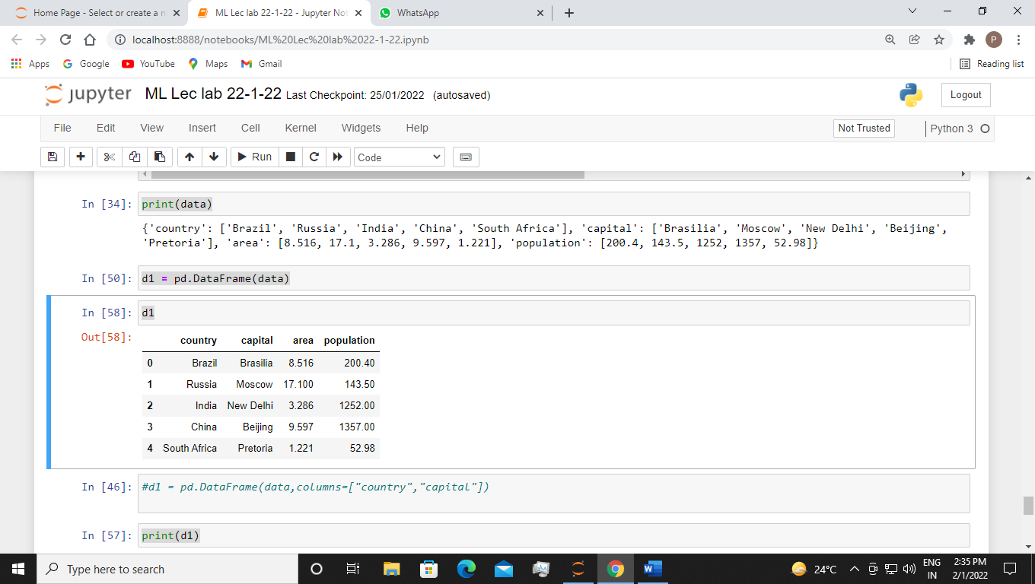

d1 = pd.DataFrame(data)

d1



print(d1)

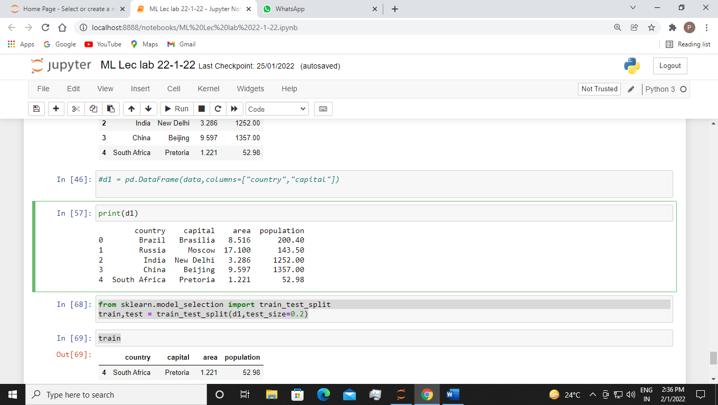

from sklearn.model_selection import train_test_split

train,test = train_test_split(d1,test_size=0.2)

train

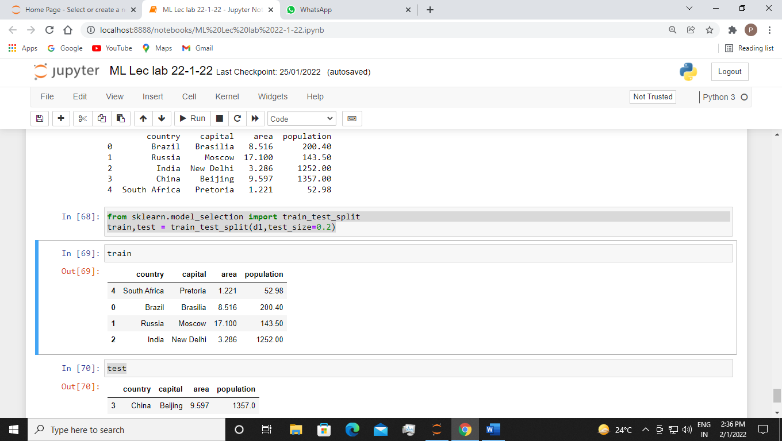

test

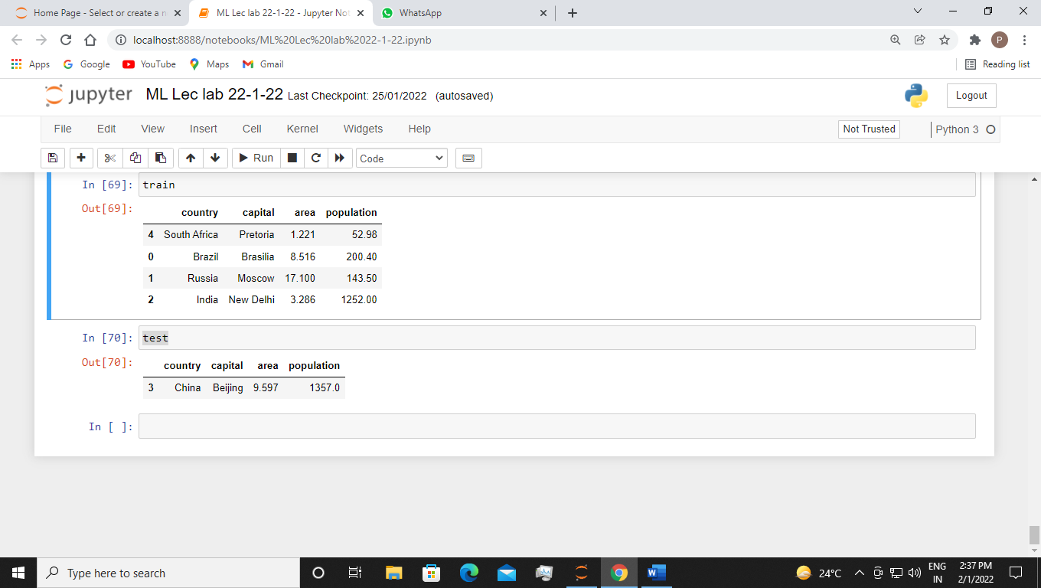

Experiment 1 (b)

Using appropriate dataset, implement the following Python's Sklearn functionality for data preprocessing

1.SimpleImputer

2.LabelEncoder

3 OneHotEncoder

4.MinMaxScaler

Sol:-

Code:-

import pandas as pd

import numpy as np

dt =pd.read_csv('Data.csv')

dt

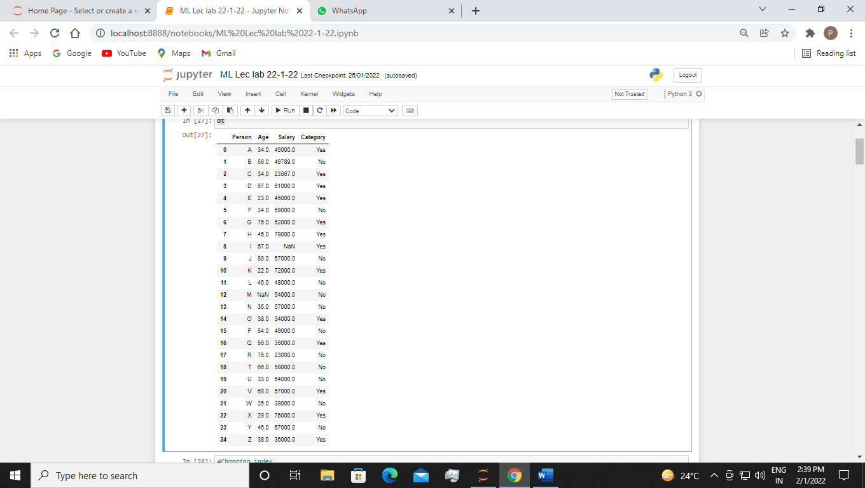

1. Simple Imputer:-

#Changing index

from sklearn.impute import SimpleImputer

imp = SimpleImputer(missing_values = np.nan ,strategy ='constant', fill_value=45)

imp.fit(dt.iloc[:,1:2])

dt.iloc[:,1:2] = imp.transform(dt.iloc[:,1:2])

dt

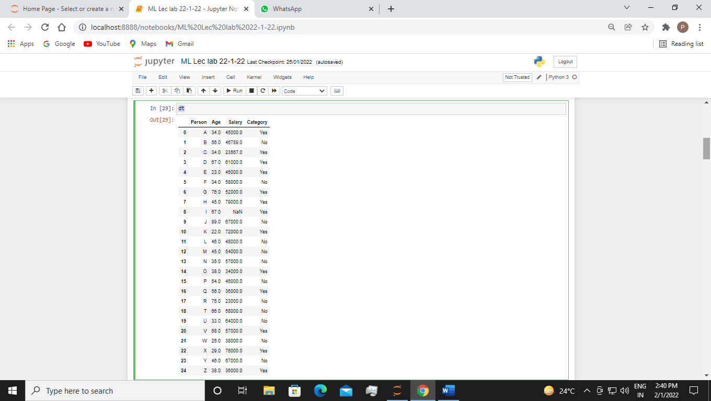

1. Label Encoder:-

#Label Encoder

from sklearn.preprocessing import LabelEncoder

l = LabelEncoder()

dt.iloc[:,-1] = l.fit_transform(dt.iloc[:,-1])

dt

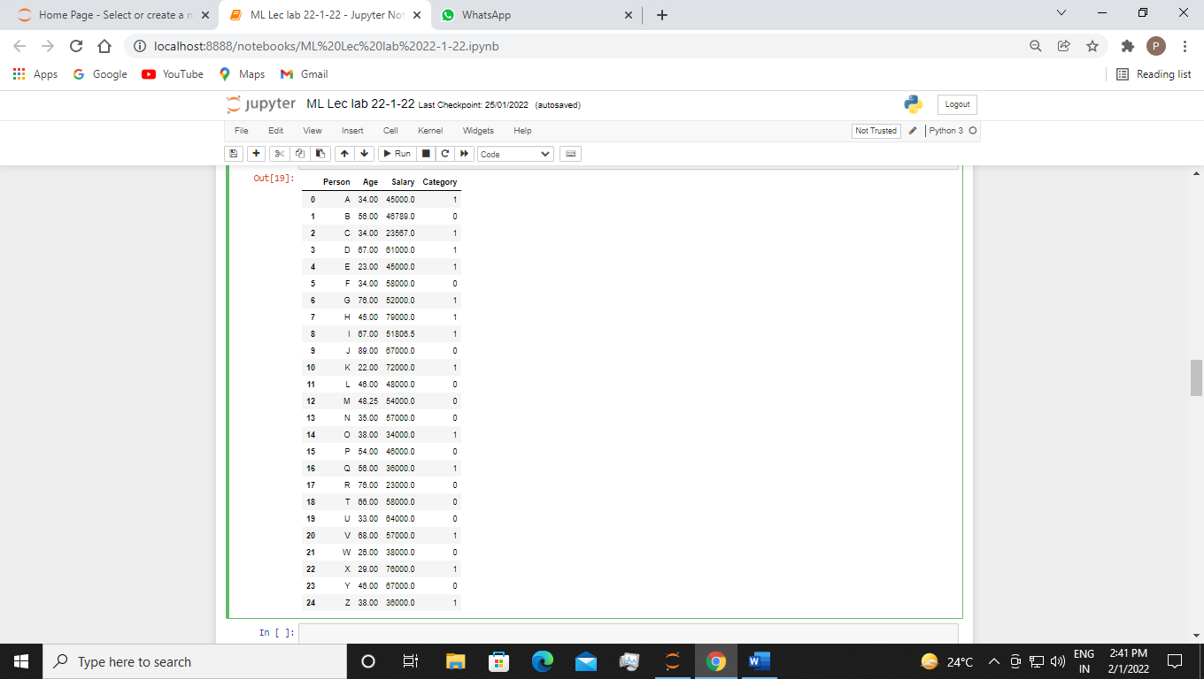

#24-1-22

#ML LEC LAB

#transformation

import pandas as pd

import numpy as np

from sklearn.compose import ColumnTransformer

from sklearn.preprocessing import OneHotEncoder

ct=ColumnTransformer(transformers =[('encoder',OneHotEncoder(),[3])],remainder = 'passthrough')

data = pd.DataFrame(ct.fit_transform(dt))

data

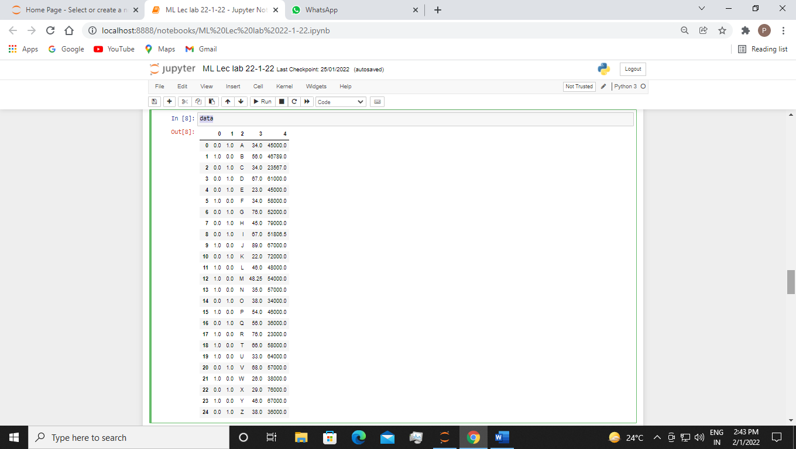

#25-1-22

#ML LAB 1

dt1 =pd.read_csv('Data1.csv')

dt1

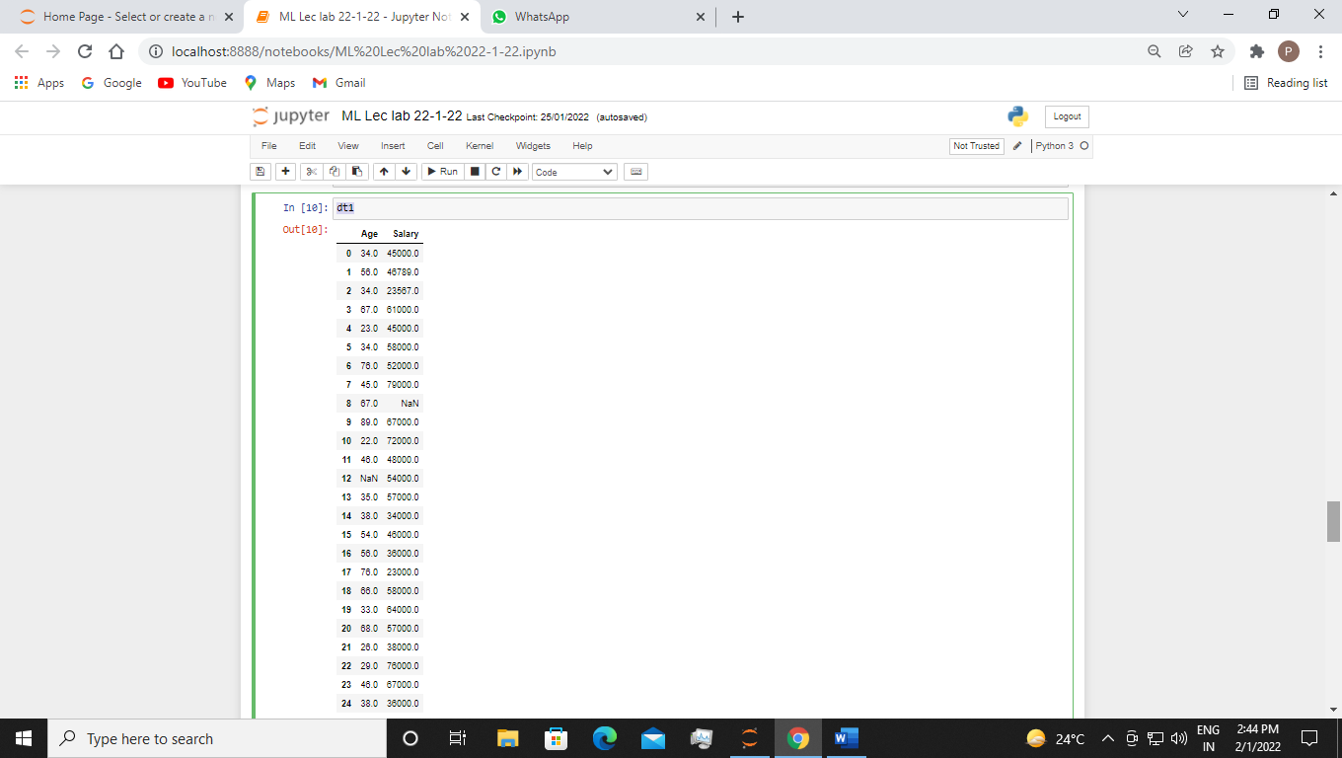

from sklearn.impute import SimpleImputer

imp1 = SimpleImputer(missing_values=np.nan,strategy = 'mean')

imp1.fit(dt1.iloc[:,0:2])

dt1.iloc[:,0:2] = imp1.transform(dt1.iloc[:,0:2])

from sklearn.preprocessing import MinMaxScaler

s= MinMaxScaler()

dt1 = pd.DataFrame(s.fit_transform(dt1))

dt1

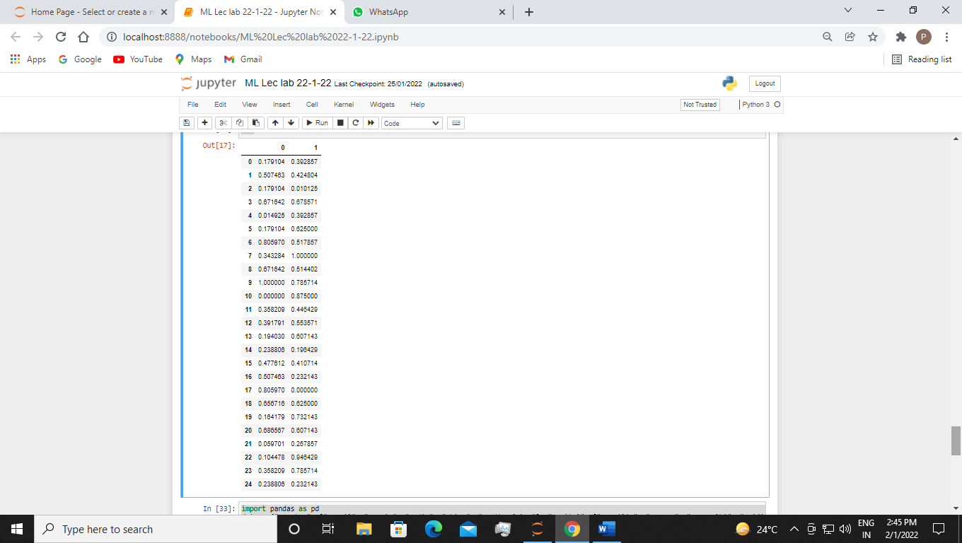

**EXPERIMENT 2**

For Data Visualization, univariate and multivariate plotting schemes are used to

understand ML data with statistics. Considering appropriate datasets from

standard repositories, built pandas dataframes and plot the following plots using

matplotlib graph plotting libraries in Python

(i) Histogram

(ii) Bar Graphs

(iii) Density Plot

(iv) Pie Charts

(v) Box and Whisker Plot

(vi) Scatter Plot

(vii) Correlation Matrix Plot/Heatmap

(viii) Scatter Matrix plot

Sol:-

(i) Histogram

Code:-

#histogram

df= pd.DataFrame({'length':[1.5,0.5,1.2,0.9,3.2], 'width':[4.5,1.5,1.4,0.4,3.6]}, index=['A','B','C','D','E'])

hg = df.hist(bins = 3)

Output:-

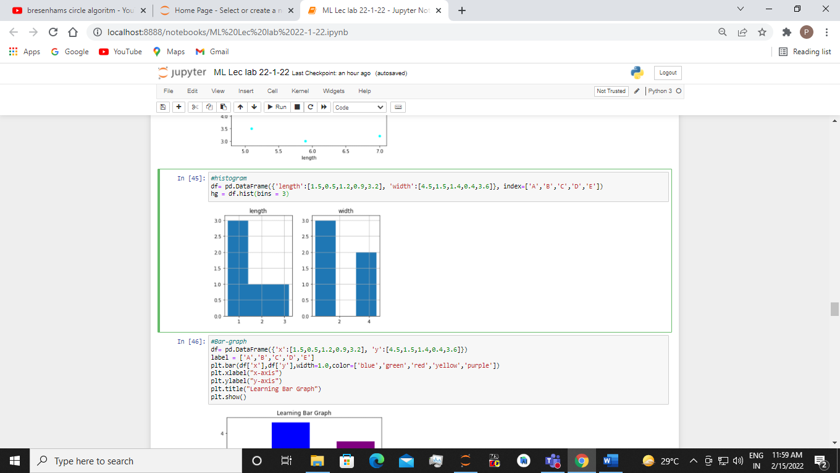

(ii) Bar Graphs

Code:-

#Bar-graph

df= pd.DataFrame({'x':[1.5,0.5,1.2,0.9,3.2], 'y':[4.5,1.5,1.4,0.4,3.6]})

label = ['A','B','C','D','E']

plt.bar(df['x'],df['y'],width=1.0,color=['blue','green','red','yellow','purple'])

plt.xlabel("x-axis")

plt.ylabel("y-axis")

plt.title("Learning Bar Graph")

plt.show()

Output:-

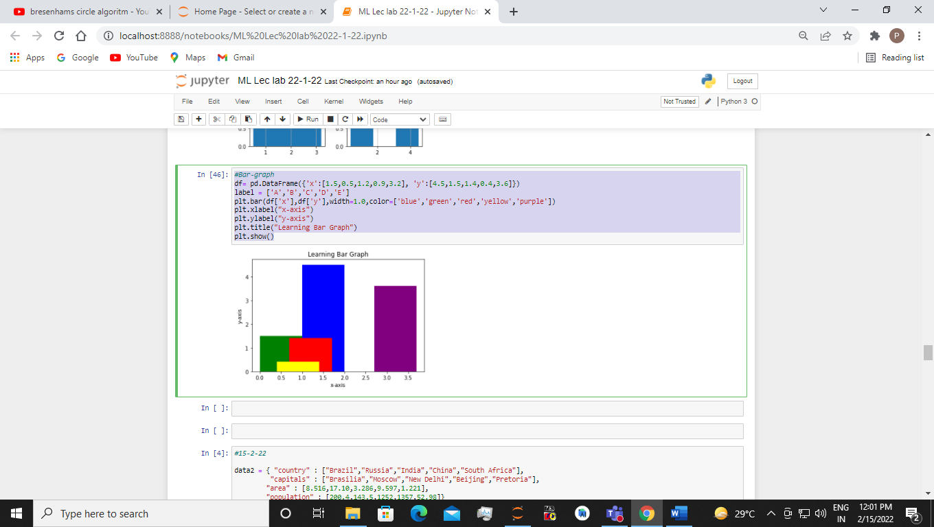

(iii) Pie Charts

Code:-

#1-2-22

#pie chart

import pandas as pd

import matplotlib.pyplot as plt

df = pd.DataFrame({'mass': [0.330,4.86,5.97], 'radius':[2457.8,6051.8,6438.4]},index=['Mercury','Venus','Earth'])

plot = df.plot.pie(y='mass',figsize=(5,5))

Output:-

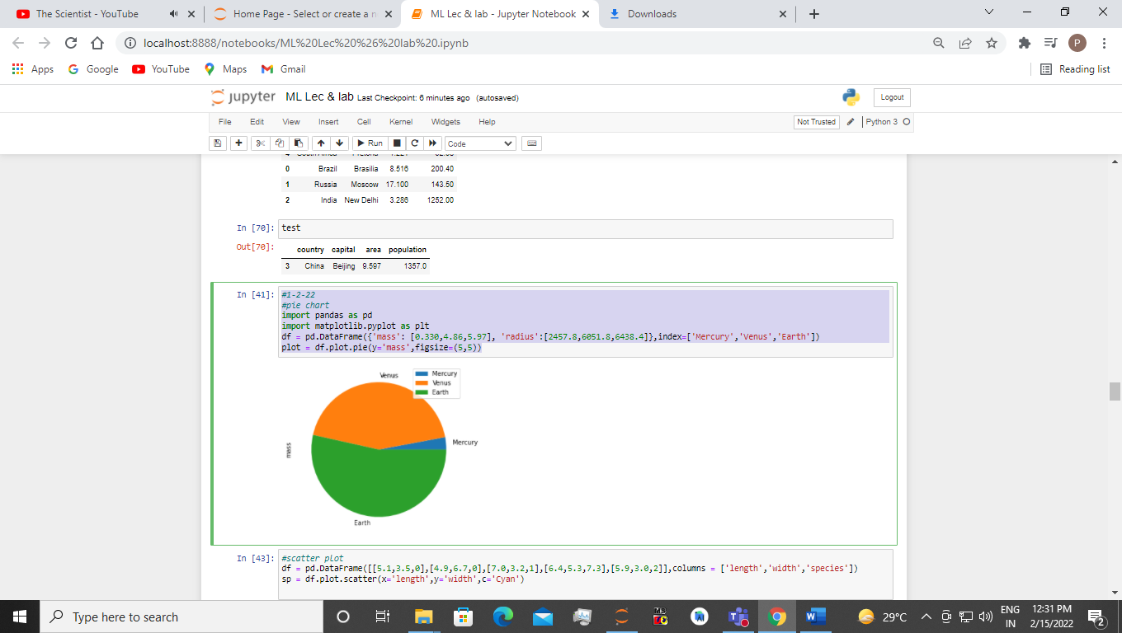

(iv) Box and Whisker Plot

Code:-

#boxplot

import matplotlib.pyplot as plt

plt.boxplot(df[['population','area']],showmeans ='True', meanline='True', labels =['population','area'],vert=True)

Output:-

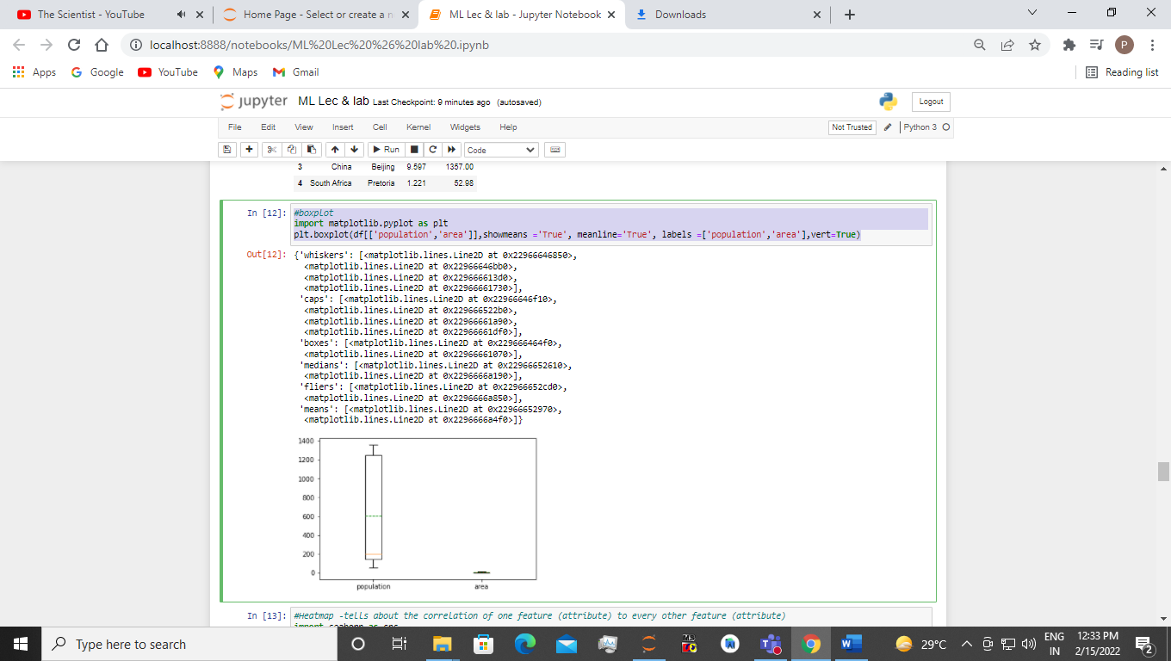

(v) Scatter Plot / Scatter Matrix plot

Code:-

#scatter plot

df = pd.DataFrame([[5.1,3.5,0],[4.9,6.7,0],[7.0,3.2,1],[6.4,5.3,7.3],[5.9,3.0,2]],columns = ['length','width','species'])

sp = df.plot.scatter(x='length',y='width',c='Cyan')

Output:-

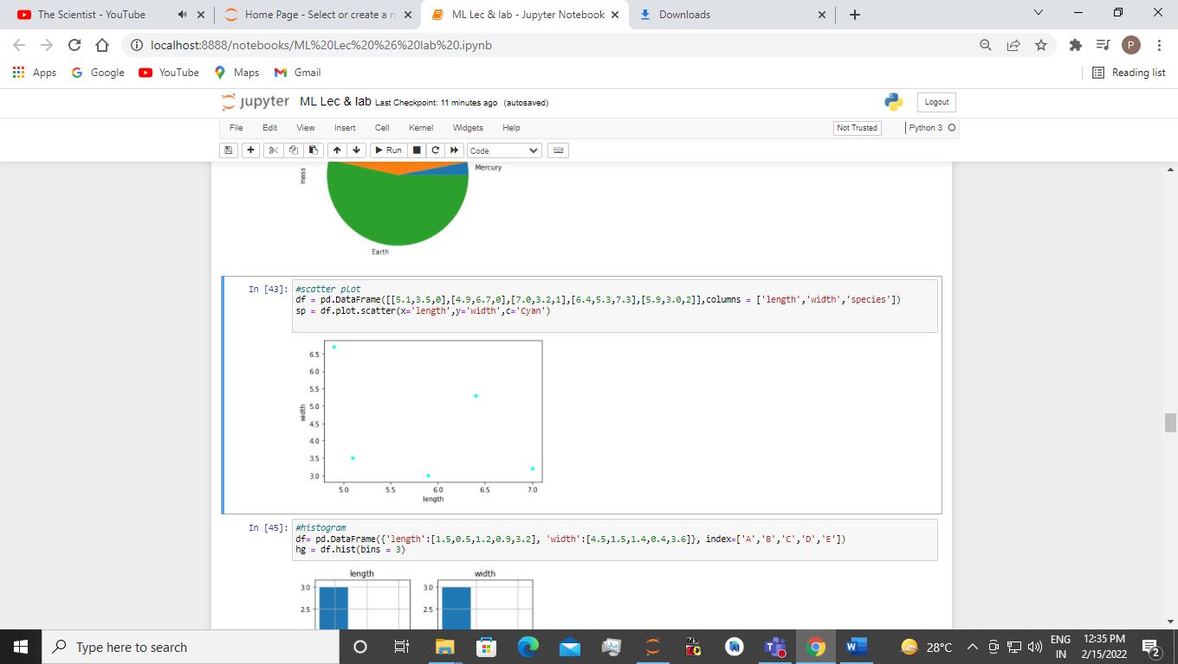

(vi) Correlation Matrix Plot/Heatmap

Code:-

#Heatmap -tells about the correlation of one feature (attribute) to every other feature (attribute)

import seaborn as sns

rel = sns.load_dataset("iris")

#heatmap

hm=sns.heatmap(rel.corr(),annot=True)

correlation = rel.sepal_length.corr(rel.sepal_width)

correlation

Output:-

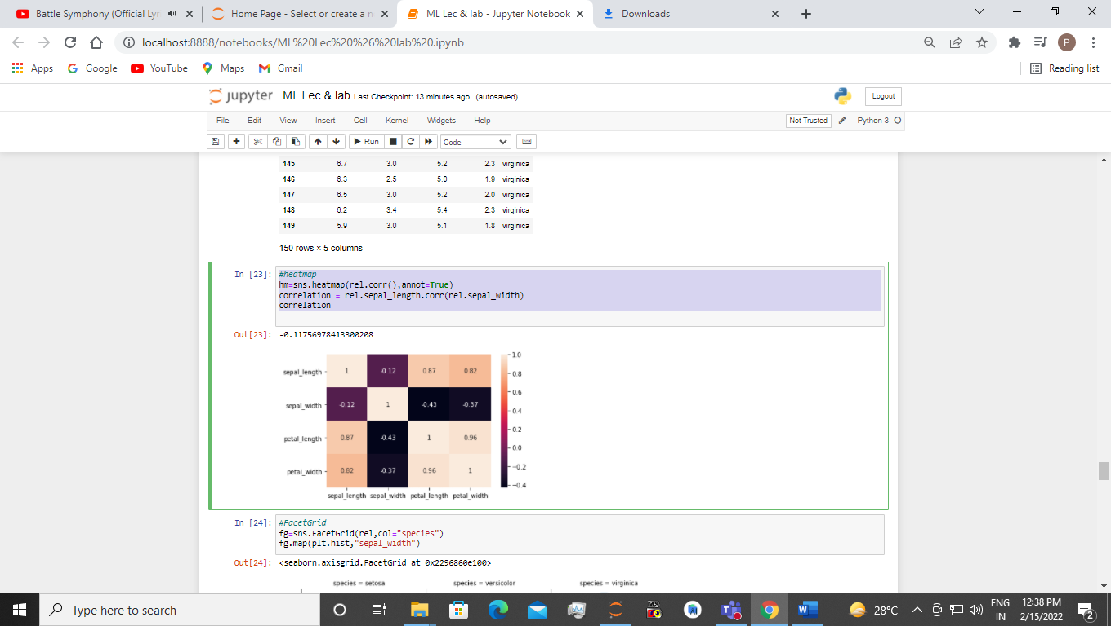

**EXPERIMENT 3**

Considering appropriate datasets from standard repositories, plot the following

using seaborn graph plotting libraries in Python.

(i) Bar Plot

(ii) Count Plot

(iii) Facet Grid

(iv) Pair Grid

(v) Relplot

Sol:-

1. Bar Plot

Code:-

import seaborn as sns

dtt=sns.load_dataset('titanic')

#Barplot

bp = sns.barplot(x="class",y="survived",hue="sex",data=dtt)

bp

Output:-

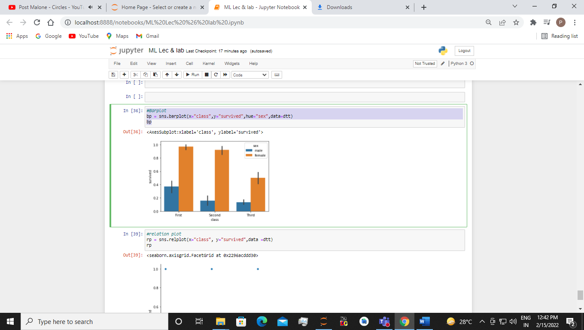

1. Count Plot

Code:-

import seaborn as sns

dtt=sns.load_dataset('titanic')

cp = sns.countplot(x='class',data=dtt)

cp

Output:-

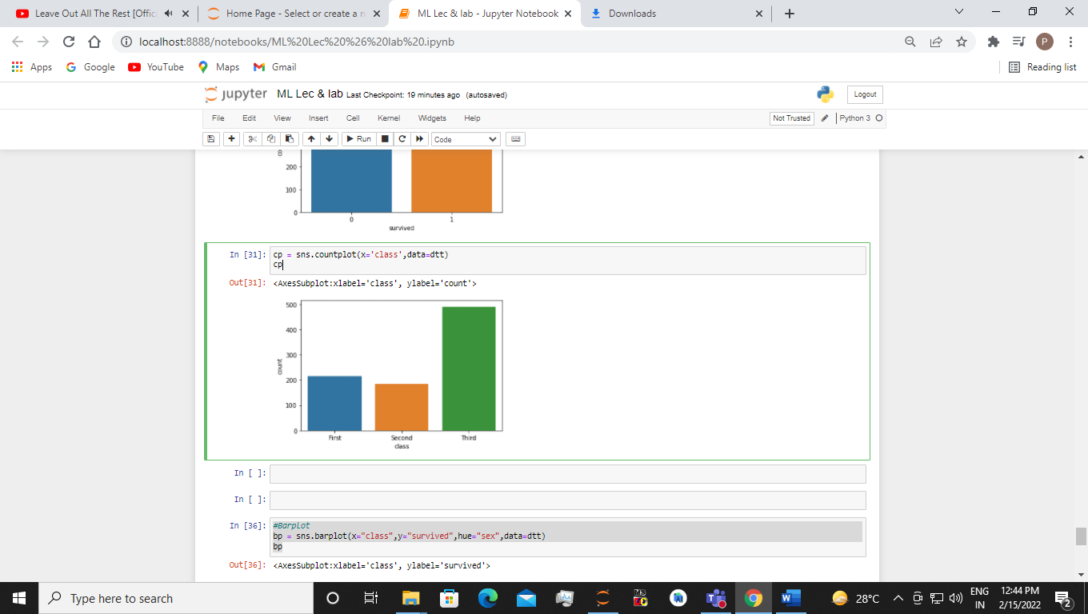

1. Facet Grid

Code:-

import seaborn as sns

rel = sns.load_dataset("iris")

#FacetGrid

fg=sns.FacetGrid(rel,col="species")

fg.map(plt.hist,"sepal_width")

fg=sns.FacetGrid(rel,col="species")

fg.map(plt.hist,"sepal_length")

Output:-

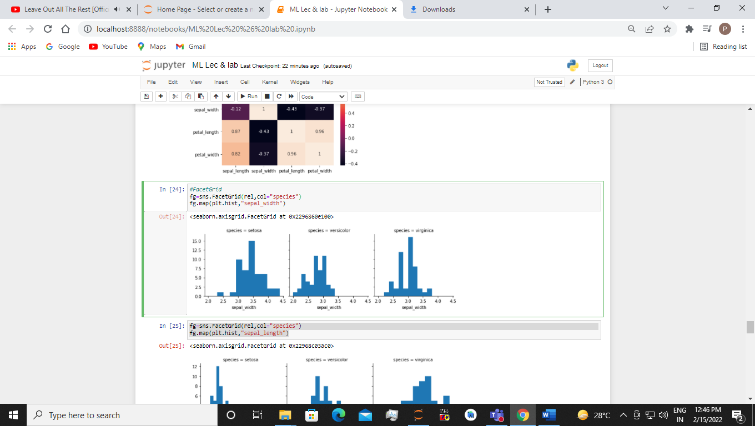

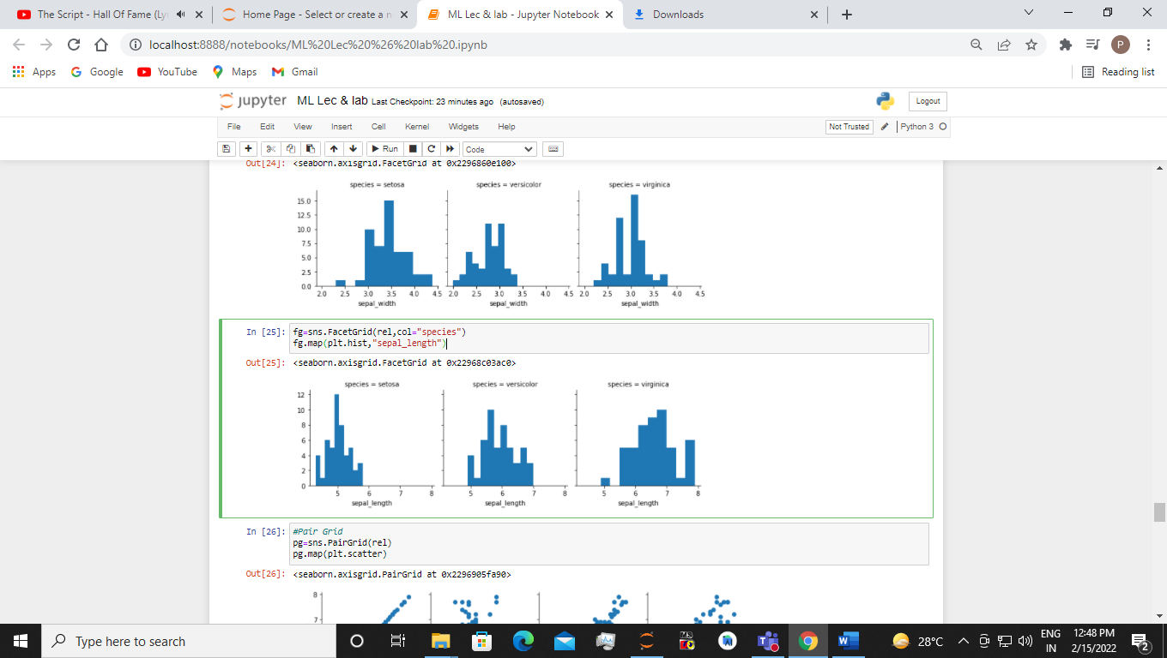

1. Pair Grid

Code:-

import seaborn as sns

rel = sns.load_dataset("iris")

#Pair Grid

pg=sns.PairGrid(rel)

pg.map(plt.scatter)

Output:-

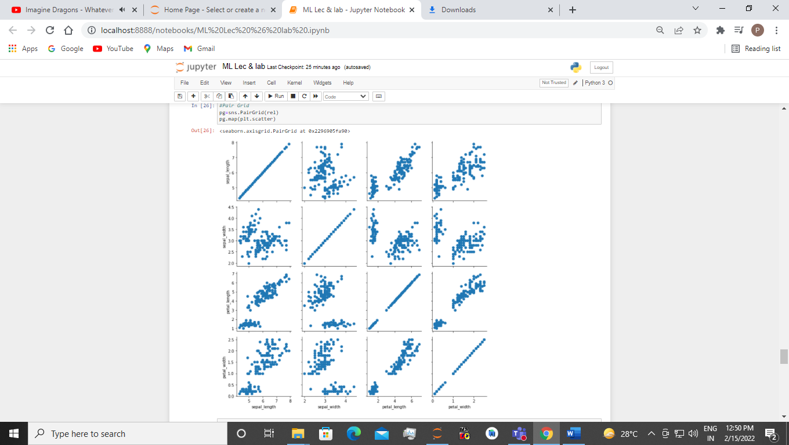

1. Relplot

Code:-

import seaborn as sns

dtt=sns.load_dataset('titanic')

#relation plot

rp = sns.relplot(x="class", y="survived",data =dtt)

rp

Output;-

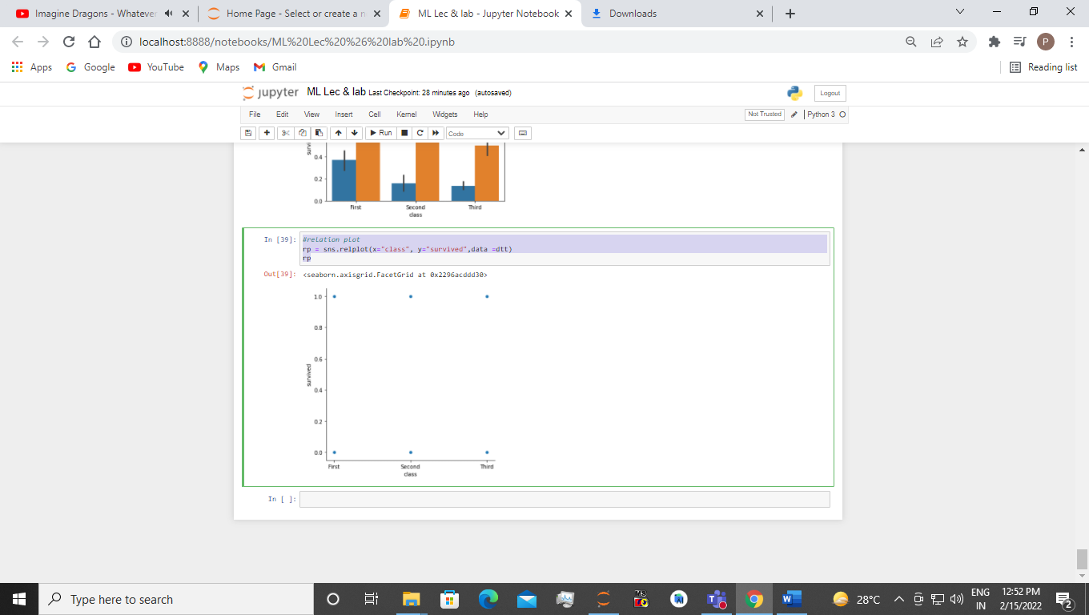

**EXPERIMENT 4**

Using an appropriate data set from standard repositories, build the decision tree using ID3 algorithmic technique. Further classify a new sample using the model.

Sol:-

import pandas as pd

import numpy as np

gd =pd.read_csv('golf_df.csv')

gd

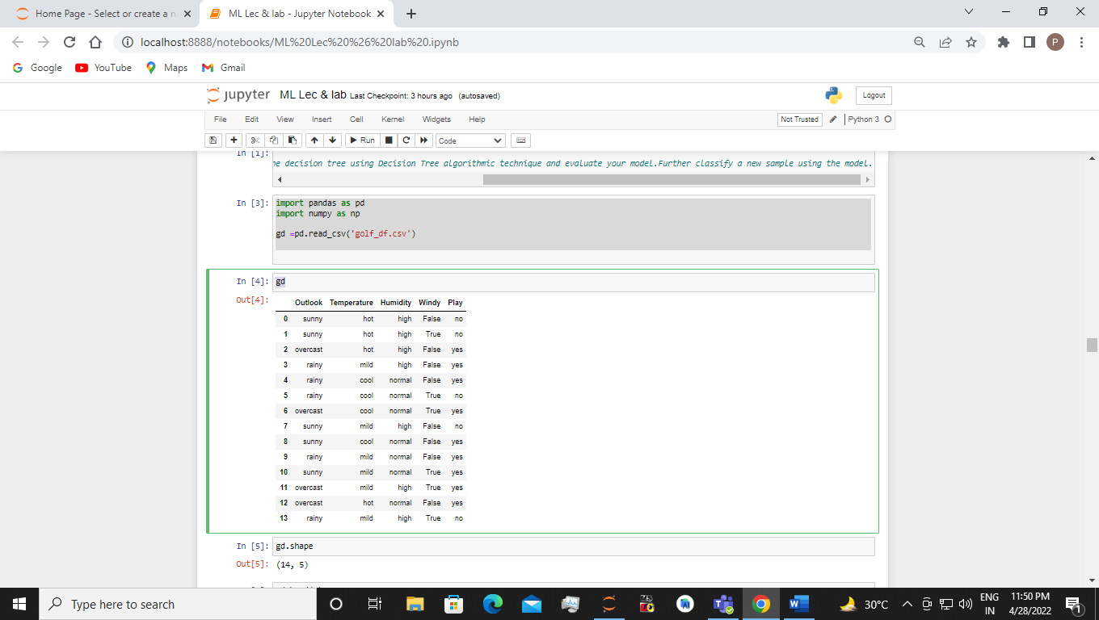

gd.shape

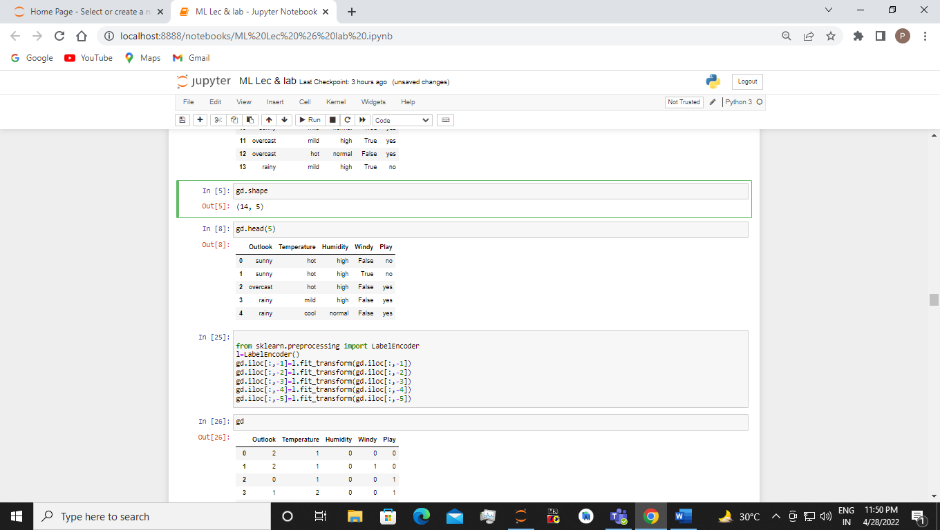

gd.head(5)

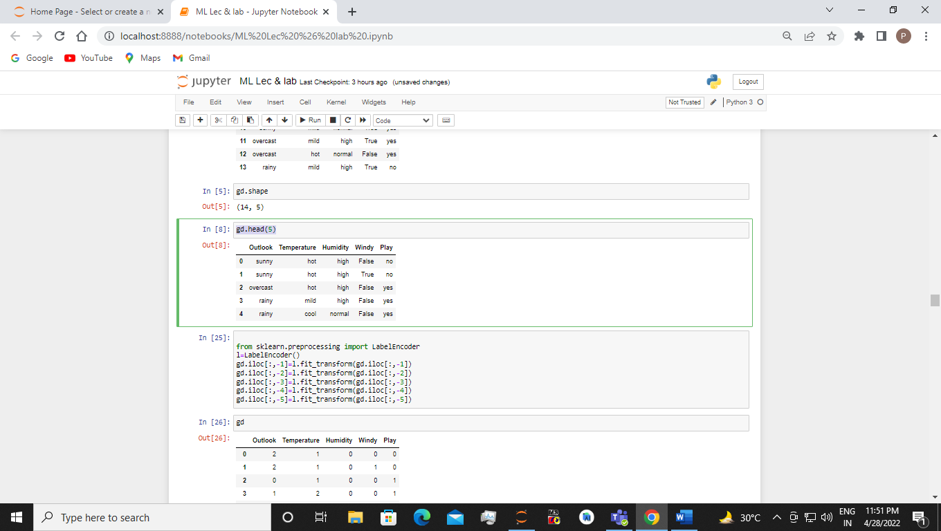

from sklearn.preprocessing import LabelEncoder

l=LabelEncoder()

gd.iloc[:,-1]=l.fit_transform(gd.iloc[:,-1])

gd.iloc[:,-2]=l.fit_transform(gd.iloc[:,-2])

gd.iloc[:,-3]=l.fit_transform(gd.iloc[:,-3])

gd.iloc[:,-4]=l.fit_transform(gd.iloc[:,-4])

gd.iloc[:,-5]=l.fit_transform(gd.iloc[:,-5])

gd

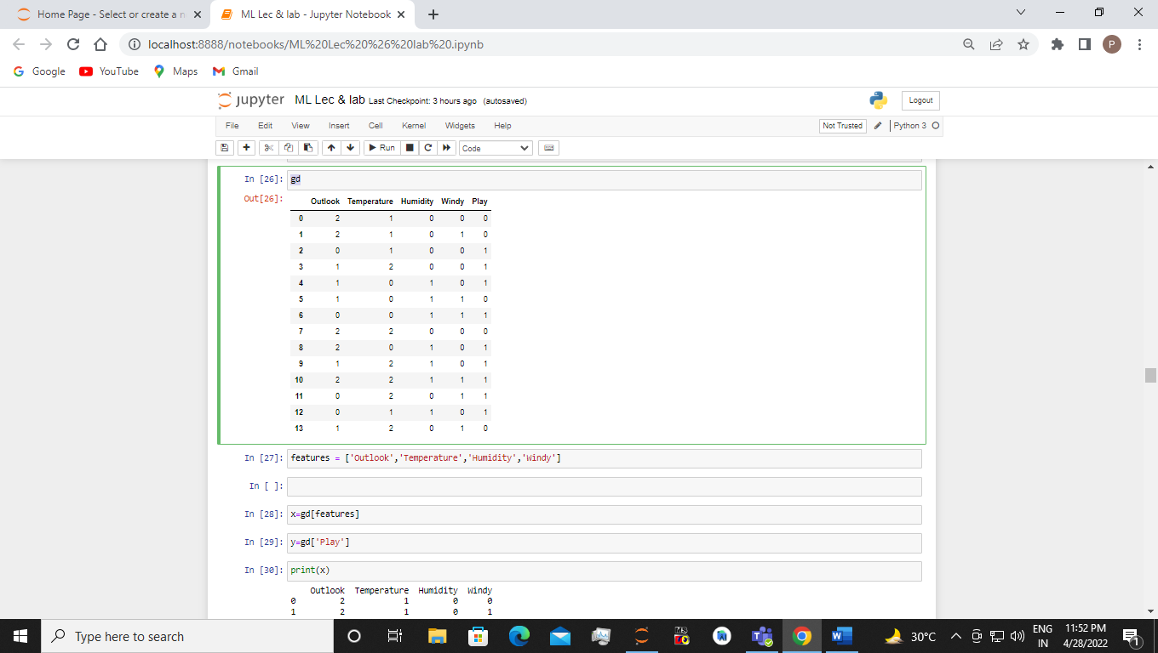

features = ['Outlook','Temperature','Humidity','Windy']

x=gd[features]

y=gd['Play']

print(x)

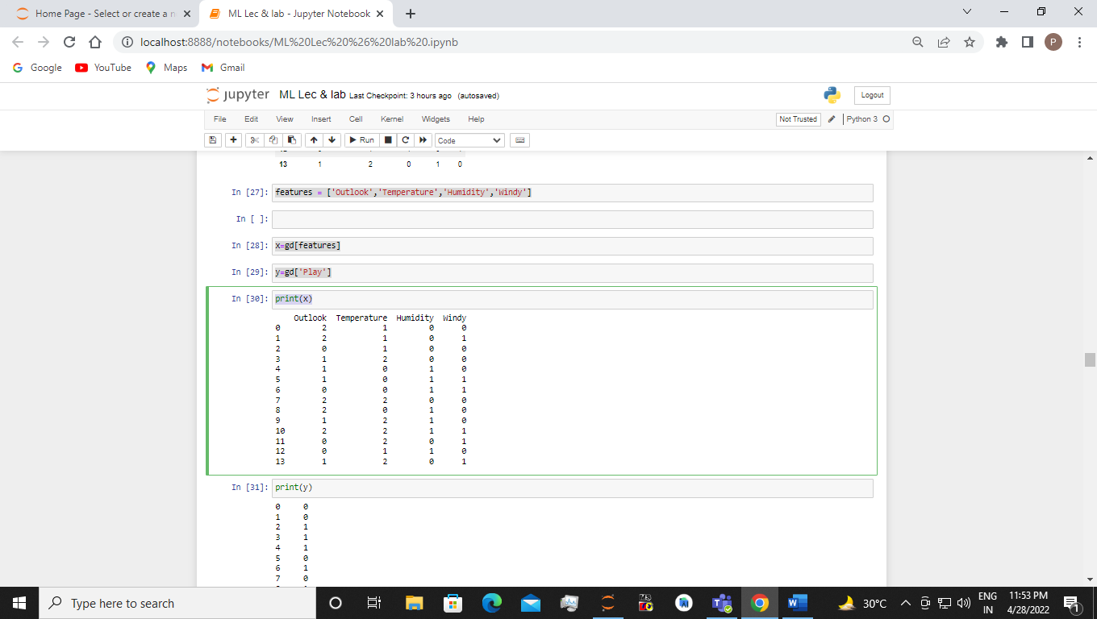

print(y)

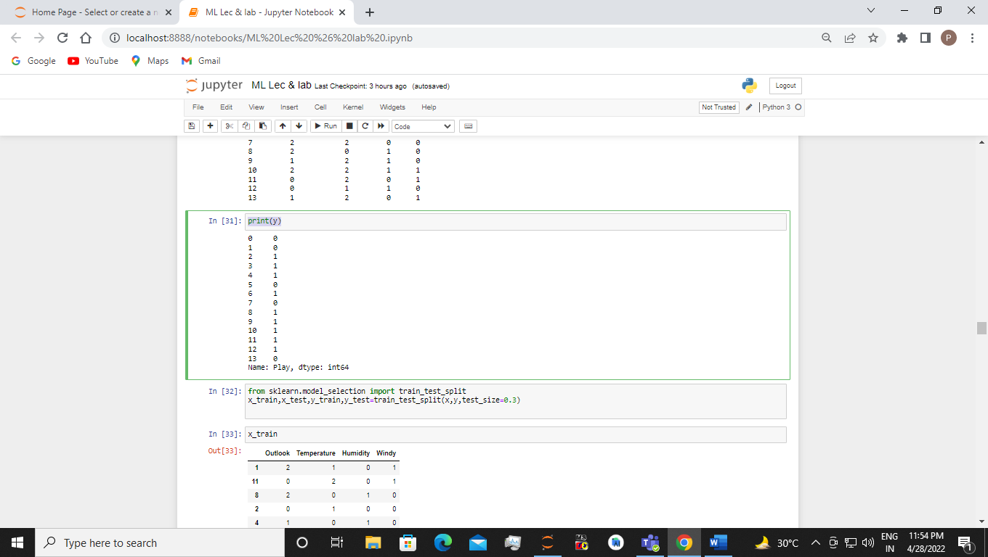

from sklearn.model_selection import train_test_split

x_train,x_test,y_train,y_test=train_test_split(x,y,test_size=0.3)

x_train

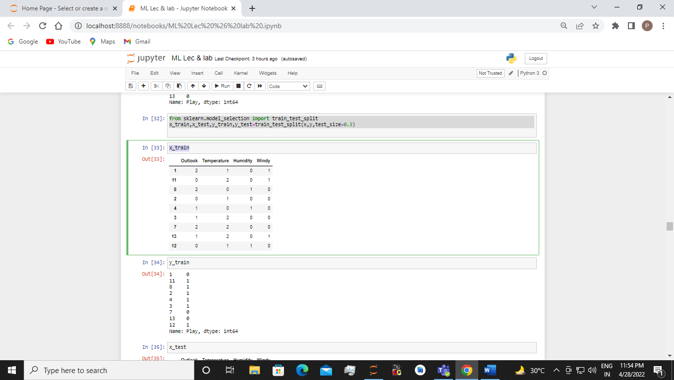

y_train

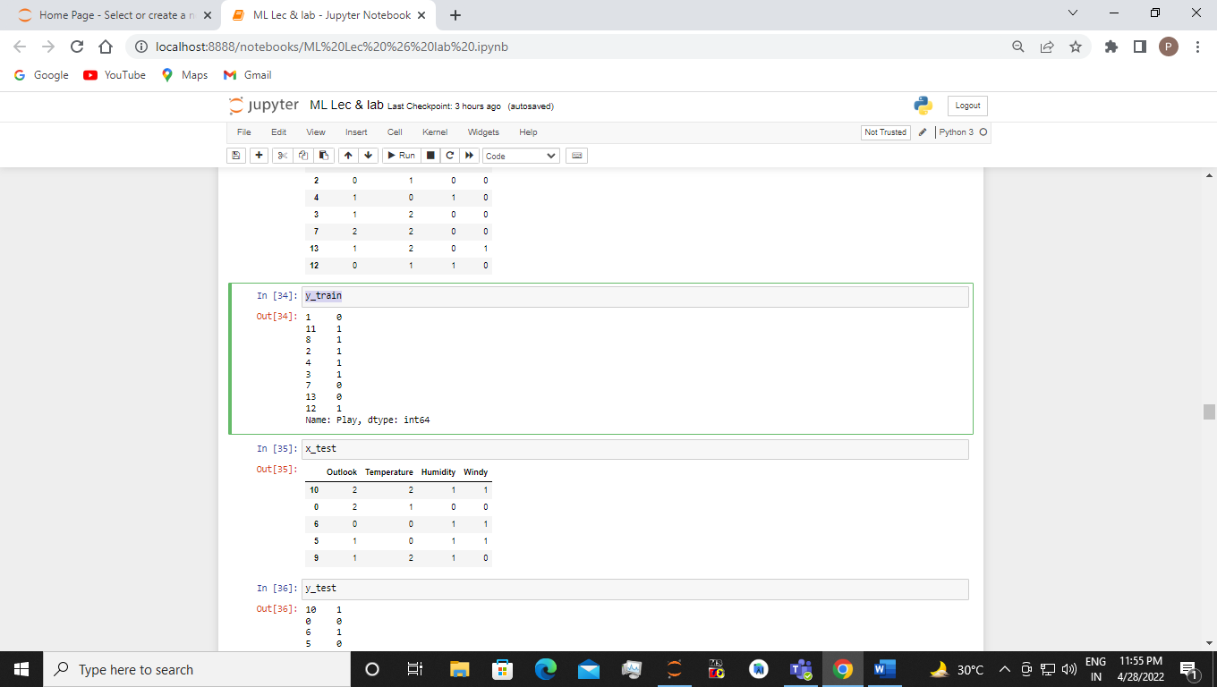

x_test

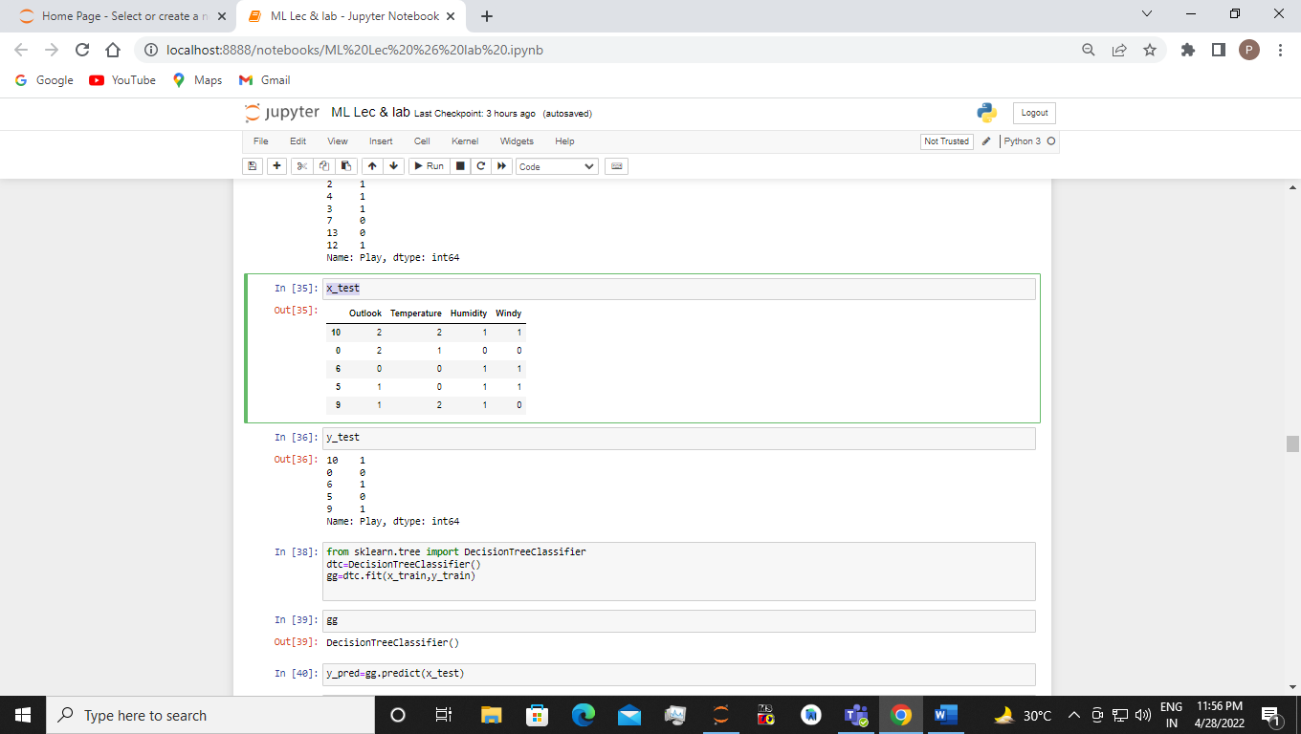

y_test

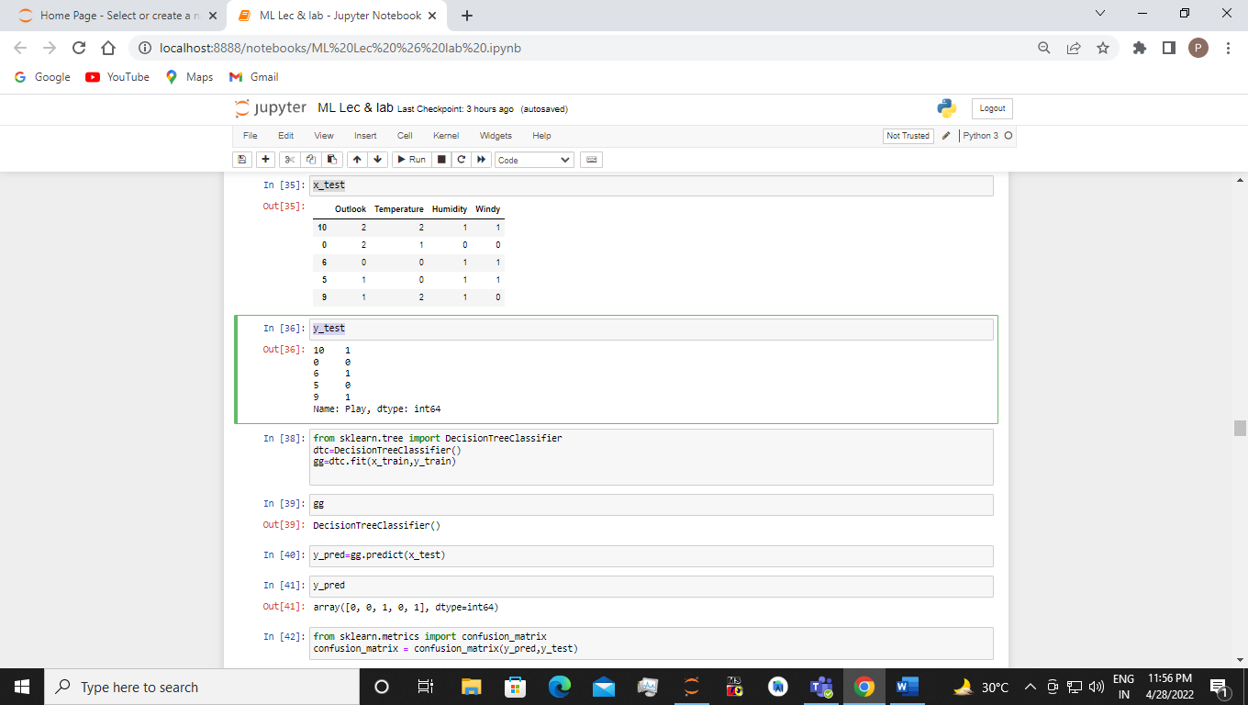

from sklearn.tree import DecisionTreeClassifier

dtc=DecisionTreeClassifier()

gg=dtc.fit(x_train,y_train)

gg

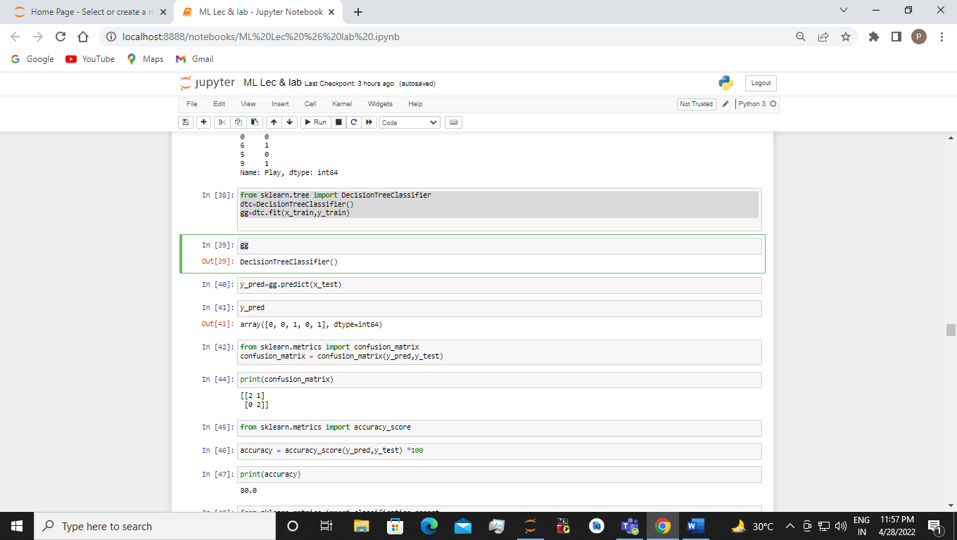

y_pred=gg.predict(x_test)

y_pred

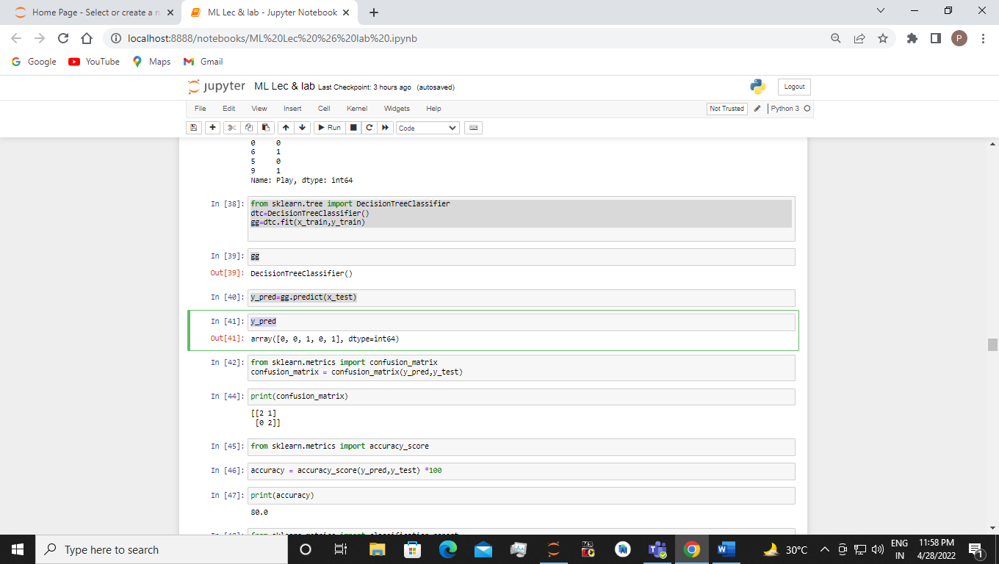

from sklearn.metrics import confusion_matrix

confusion_matrix = confusion_matrix(y_pred,y_test)

print(confusion_matrix)

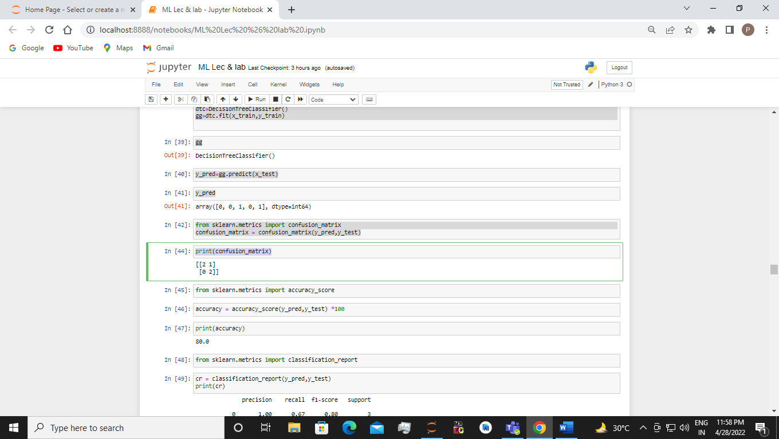

from sklearn.metrics import accuracy_score

accuracy = accuracy_score(y_pred,y_test) *100

print(accuracy)

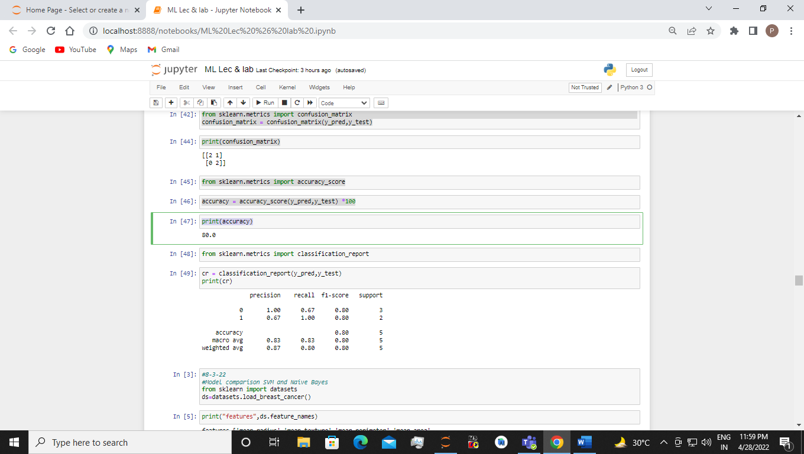

from sklearn.metrics import classification_report

cr = classification_report(y_pred,y_test)

print(cr)

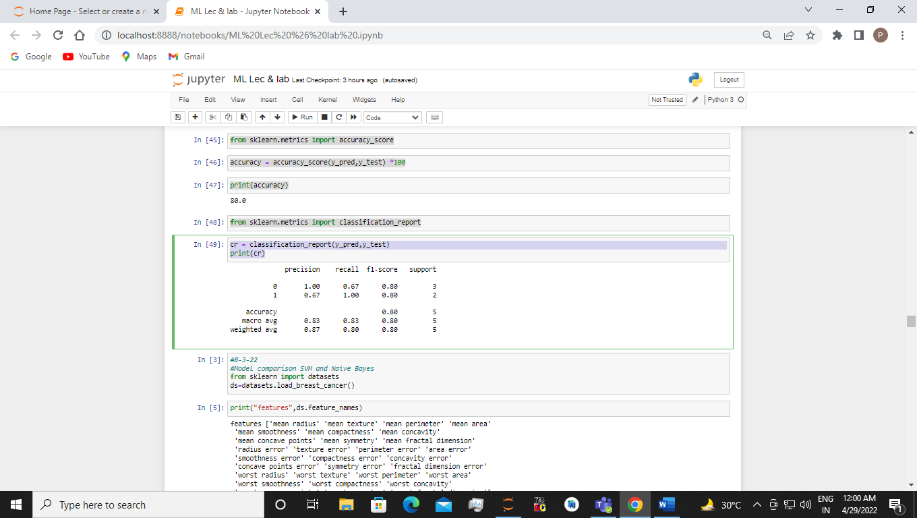

**EXPERIMENT 5**

Considering appropriate dataset, use the Scikit-learn, ML Python libraries to fit a CART model to the data. Further summarize the fit of the model depicting a confusion matrix

Sol:-

import pandas as pd

import numpy as np

df = pd.read_csv("red_wine.csv")

df.head

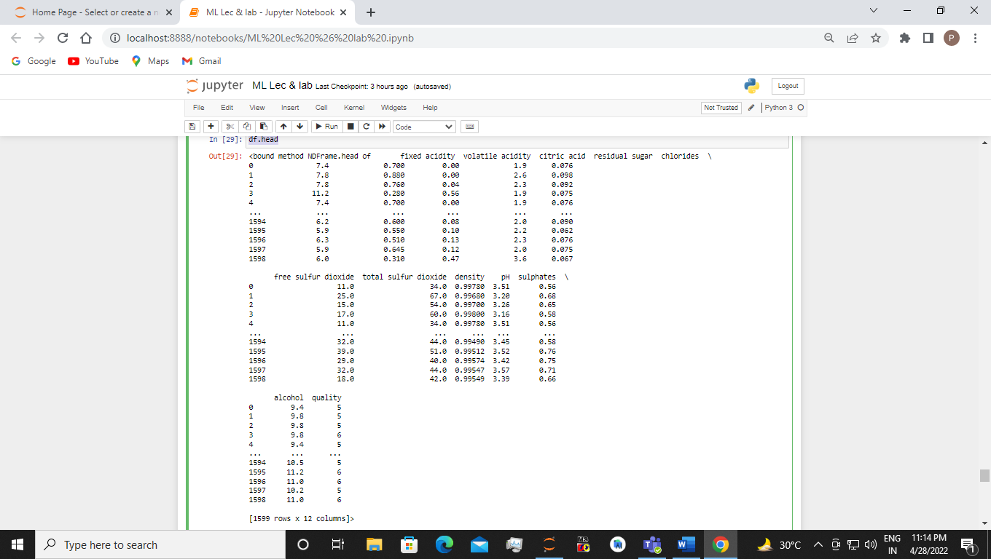

df.shape

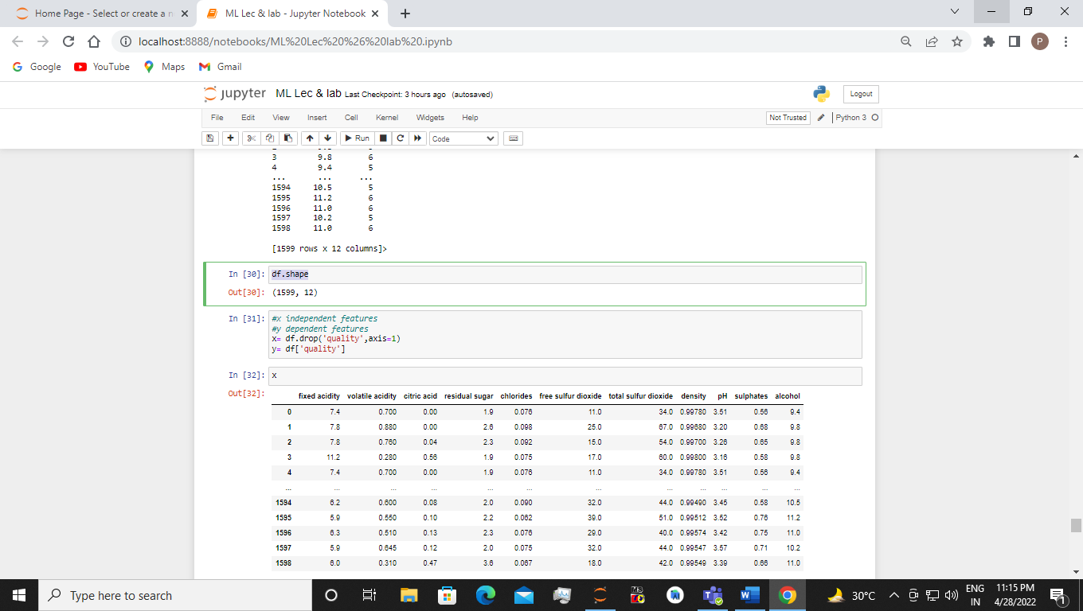

#x independent features

#y dependent features

x= df.drop('quality',axis=1)

y= df['quality']

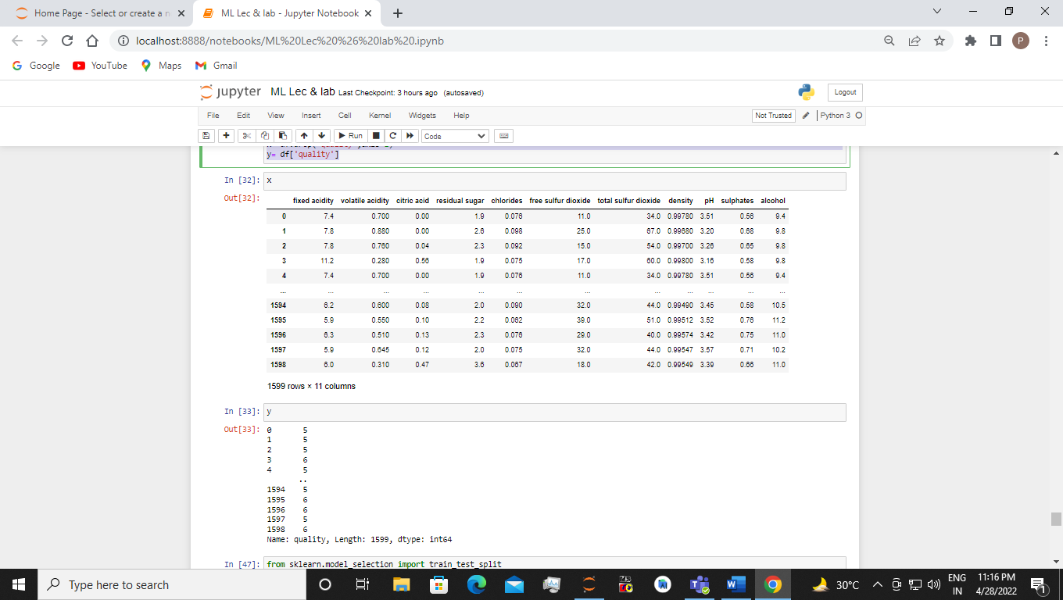

from sklearn.model_selection import train_test_split

x_train,x_test,y_train,y_test = train_test_split(x,y,test_size=0.25,shuffle=False)

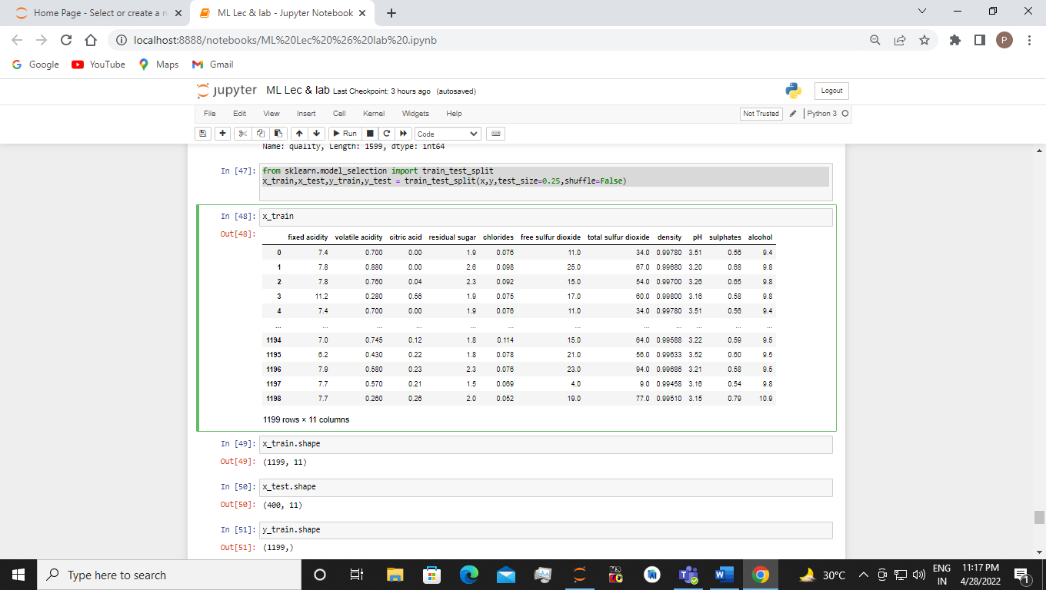

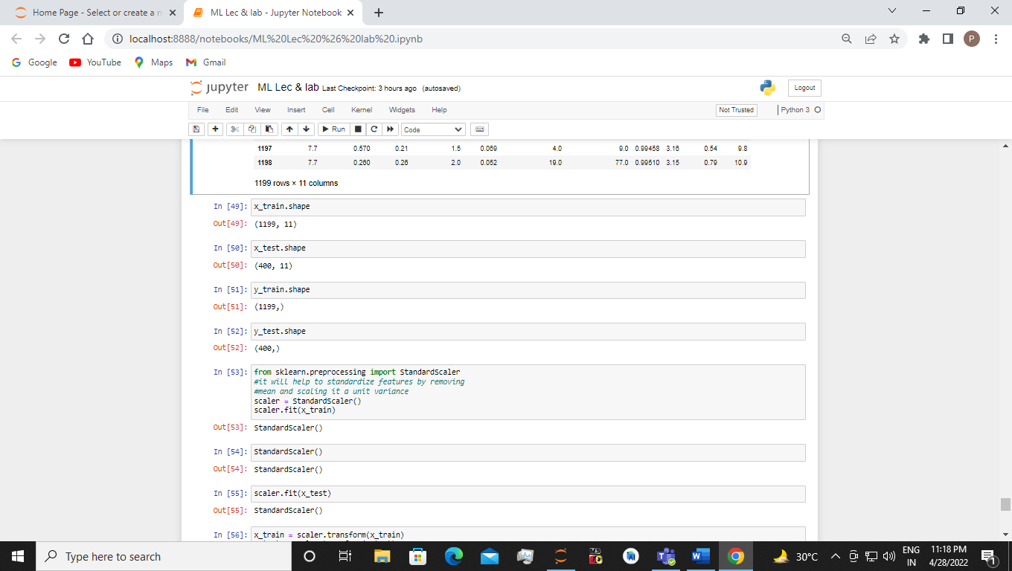

from sklearn.preprocessing import StandardScaler

#it will help to standardize features by removing

#mean and scaling it a unit variance

scaler = StandardScaler()

scaler.fit(x_train)

StandardScaler()

scaler.fit(x_test)

x_train = scaler.transform(x_train)

x_test = scaler.transform(x_test)

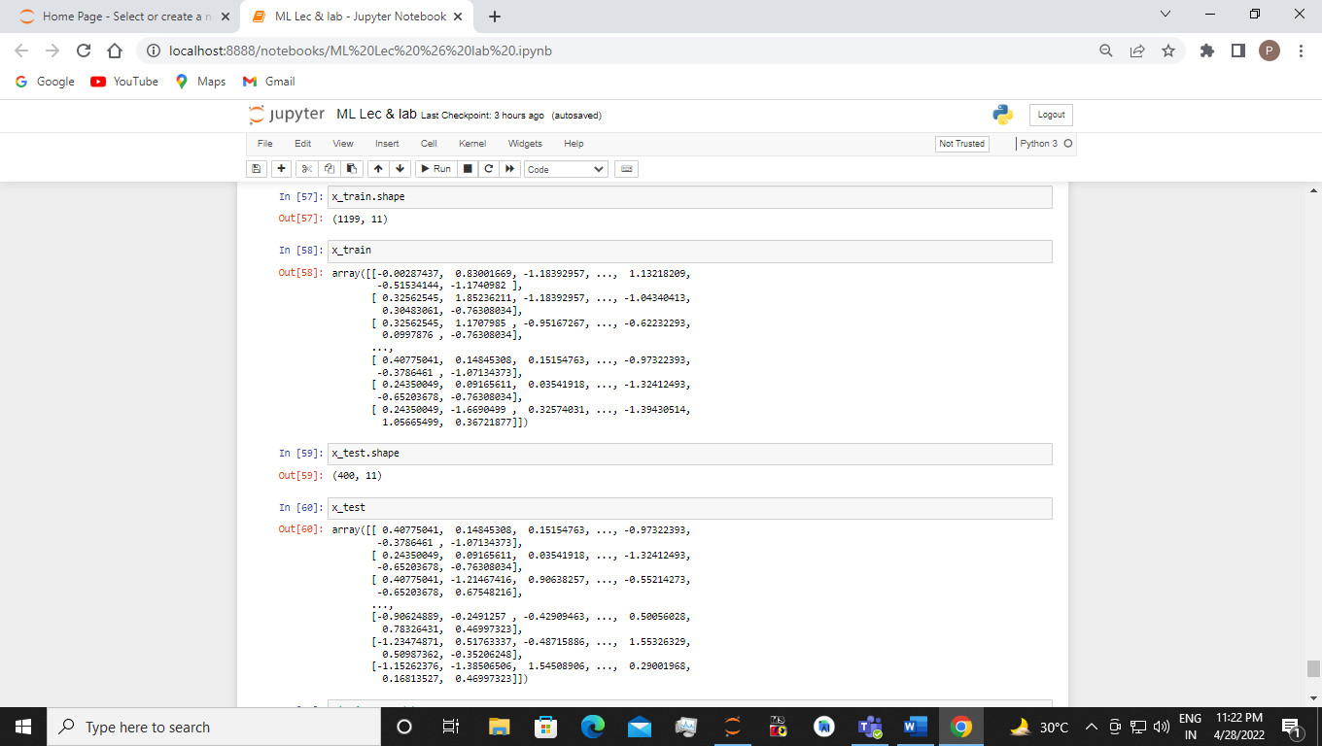

#train my model

from sklearn.neural_network import MLPClassifier

mlp = MLPClassifier(hidden_layer_sizes = (13,13,13), max_iter=1500, activation = 'relu')

mlp.fit(x_train,y_train)

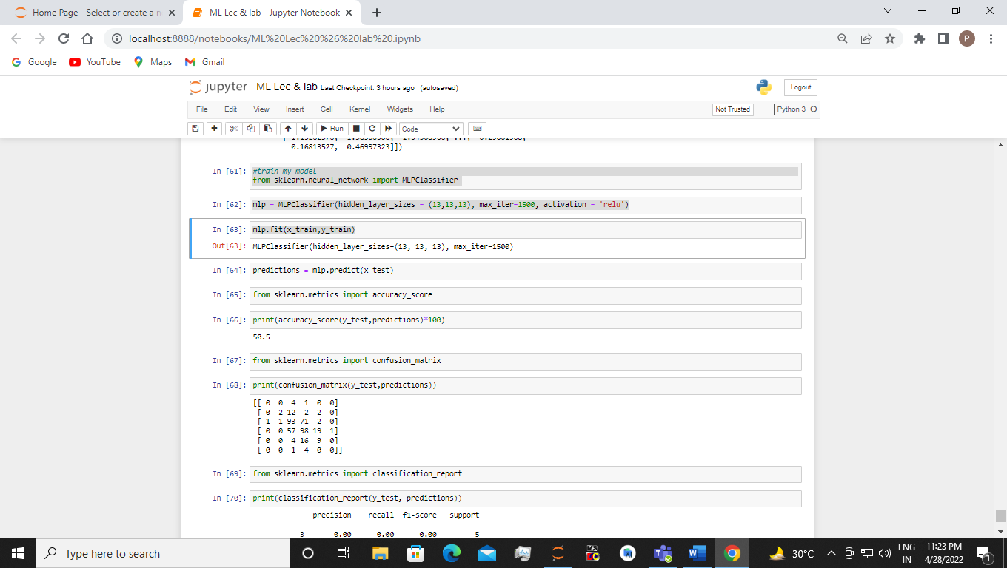

predictions = mlp.predict(x_test)

from sklearn.metrics import accuracy_score

print(accuracy_score(y_test,predictions)*100)

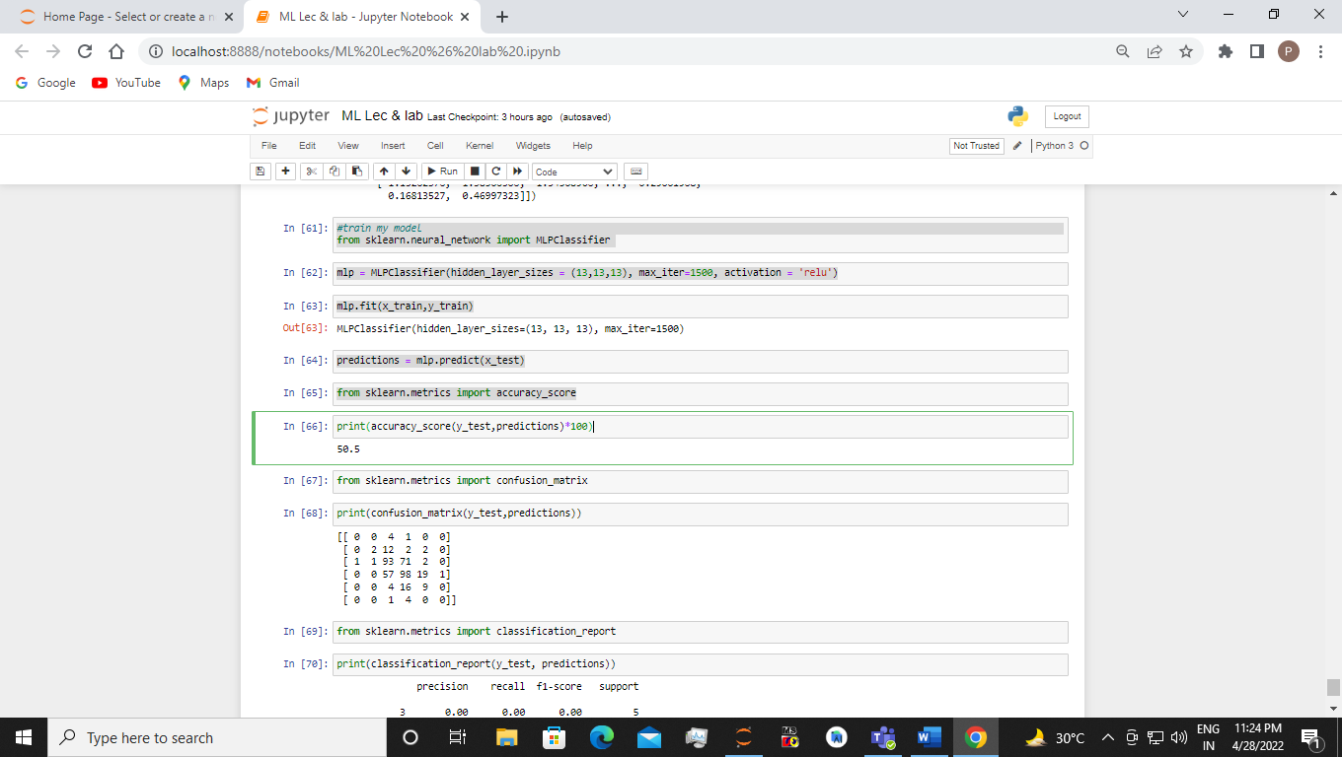

from sklearn.metrics import confusion_matrix

print(confusion_matrix(y_test,predictions))

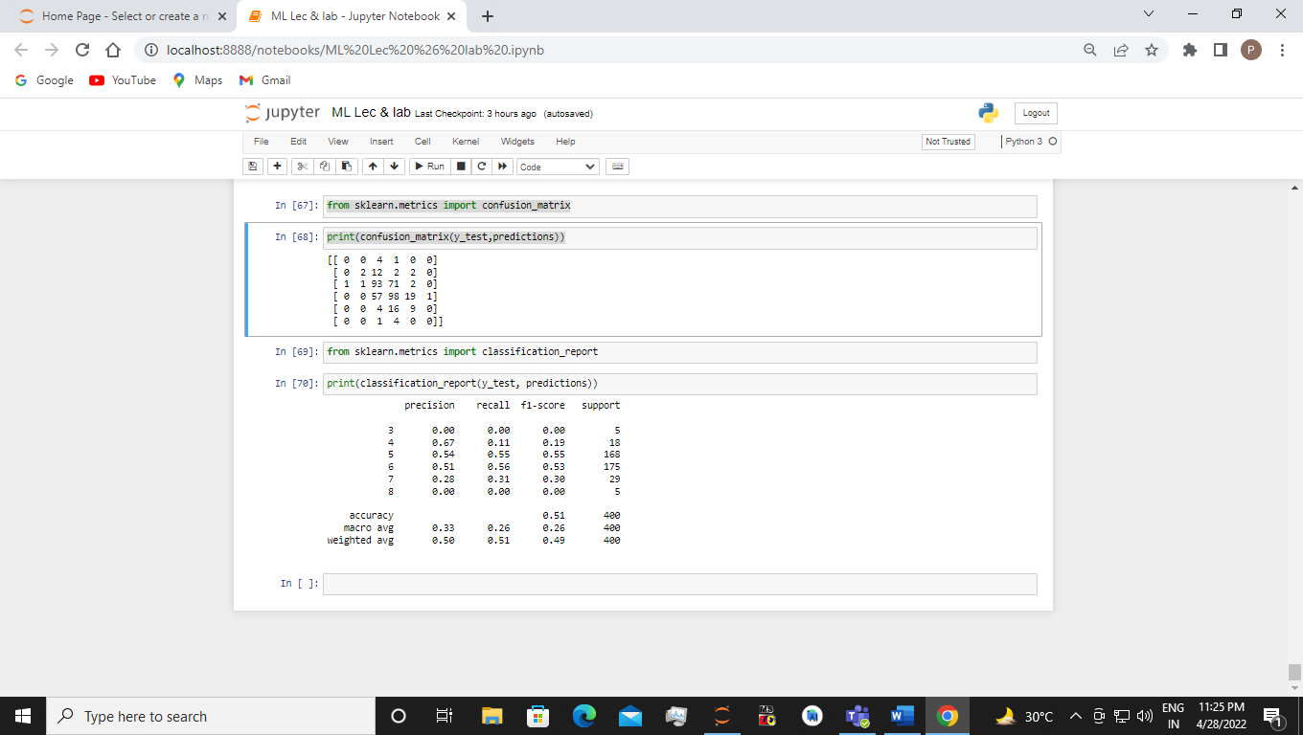

**EXPERIMENT 6**

Using an appropriate data set from standard repositories as sample training data set, implement the naïve Bayesian classification. Compute the accuracy of the classifier. Compare the classifier with the SVM Classifier on the basis of Accuracy, Precision and Recall

Sol:-

#Model comparison SVM and Naive Bayes from sklearn import datasets ds=datasets.load_breast_cancer()

print("features",ds.feature_names)

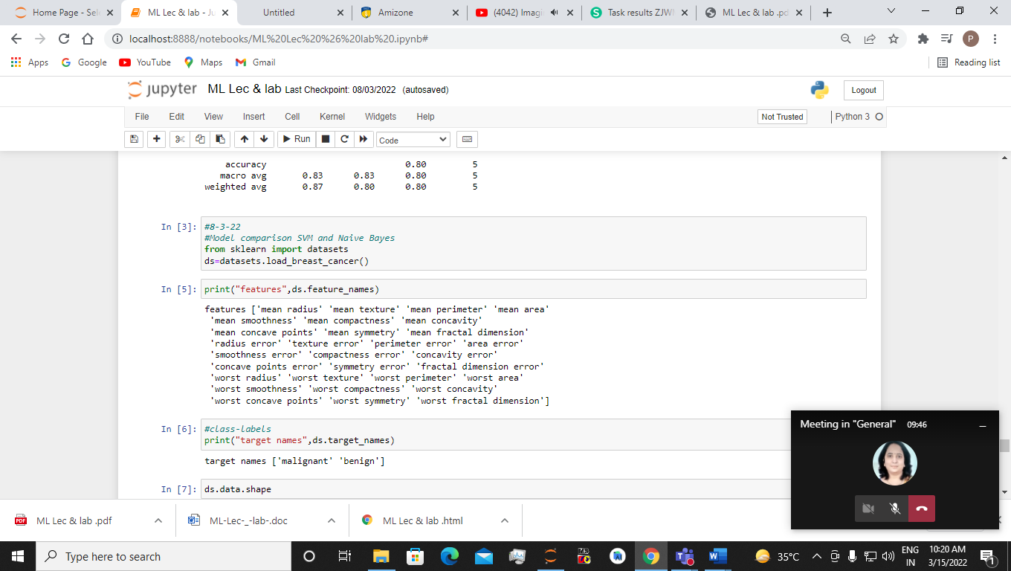

#class-labels print("target names",ds.target_names)

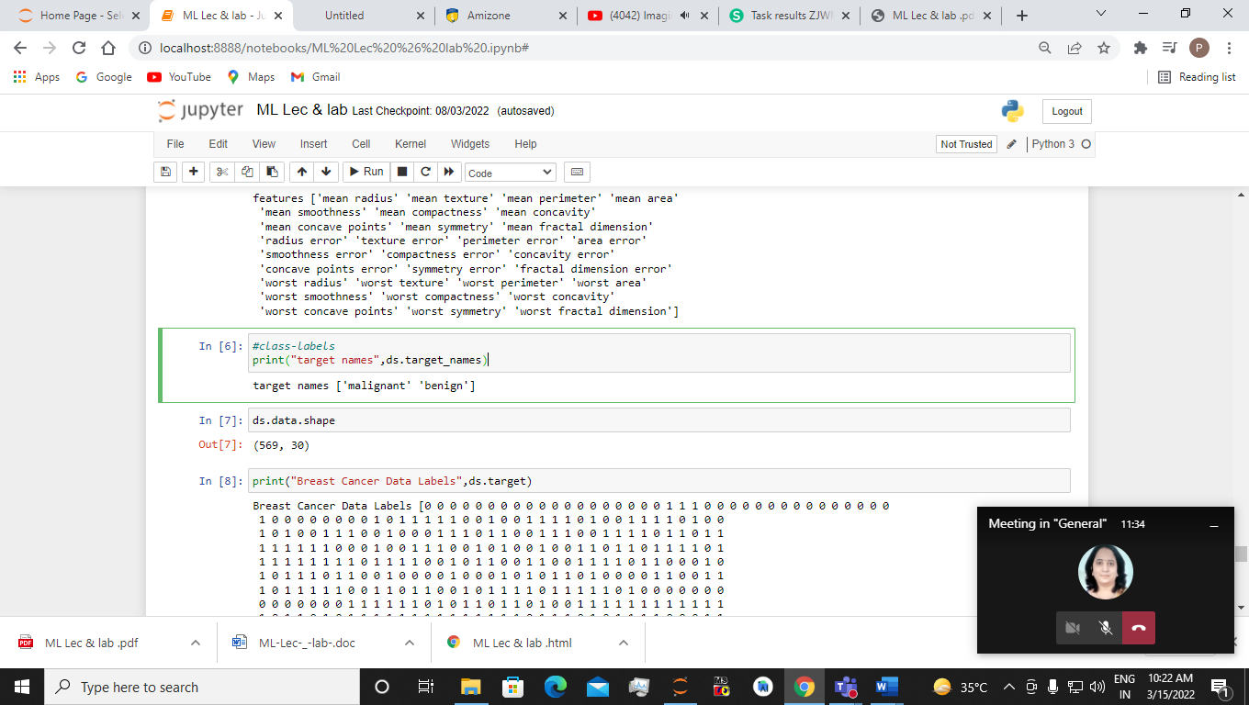

ds.data.shape



print("Breast Cancer Data Labels",ds.target)

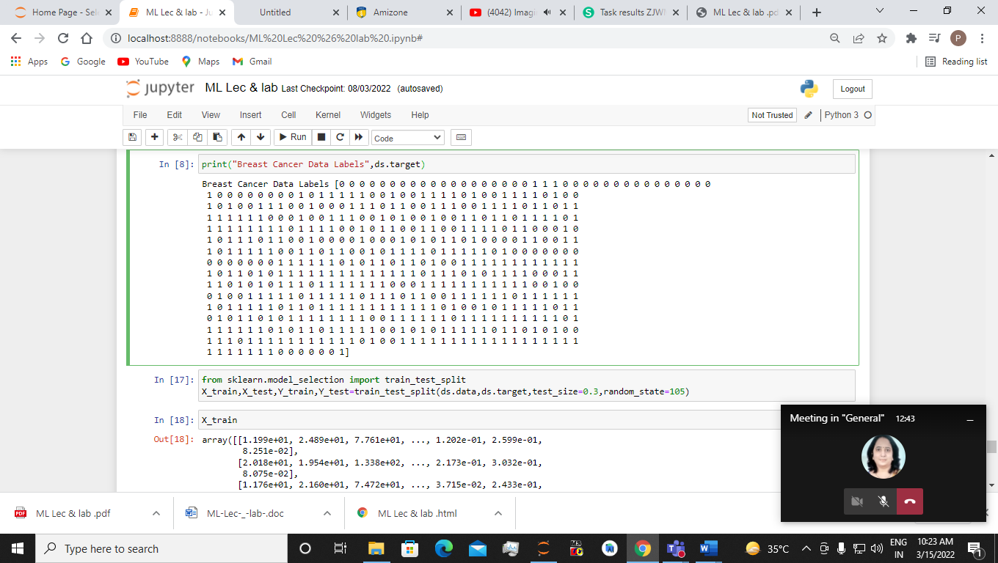

from sklearn.model_selection import train_test_split X_train,X_test,Y_train,Y_test=train_test_split(ds.data,ds.target,test_size=0.3,random_state=105)

X_train

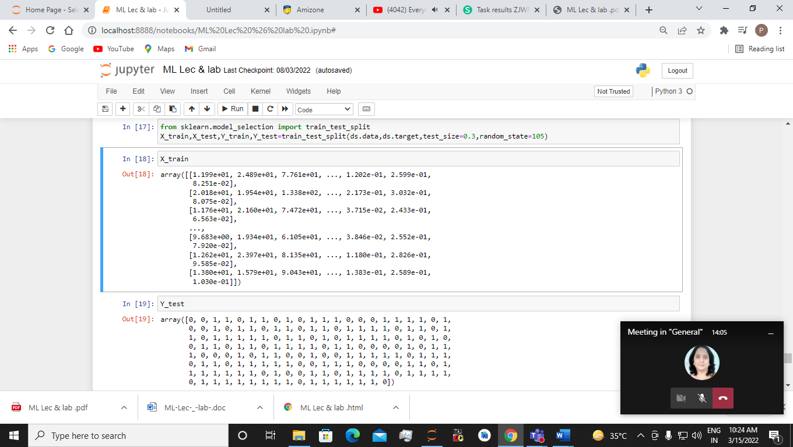

Y_test

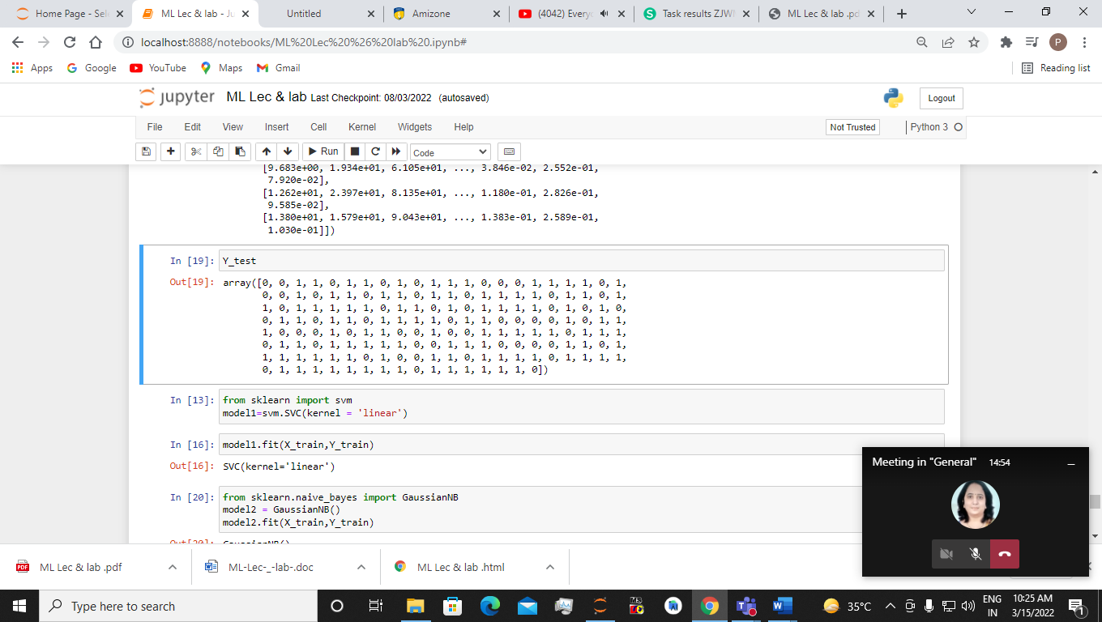

from sklearn import svm

model1=svm.SVC(kernel = 'linear')

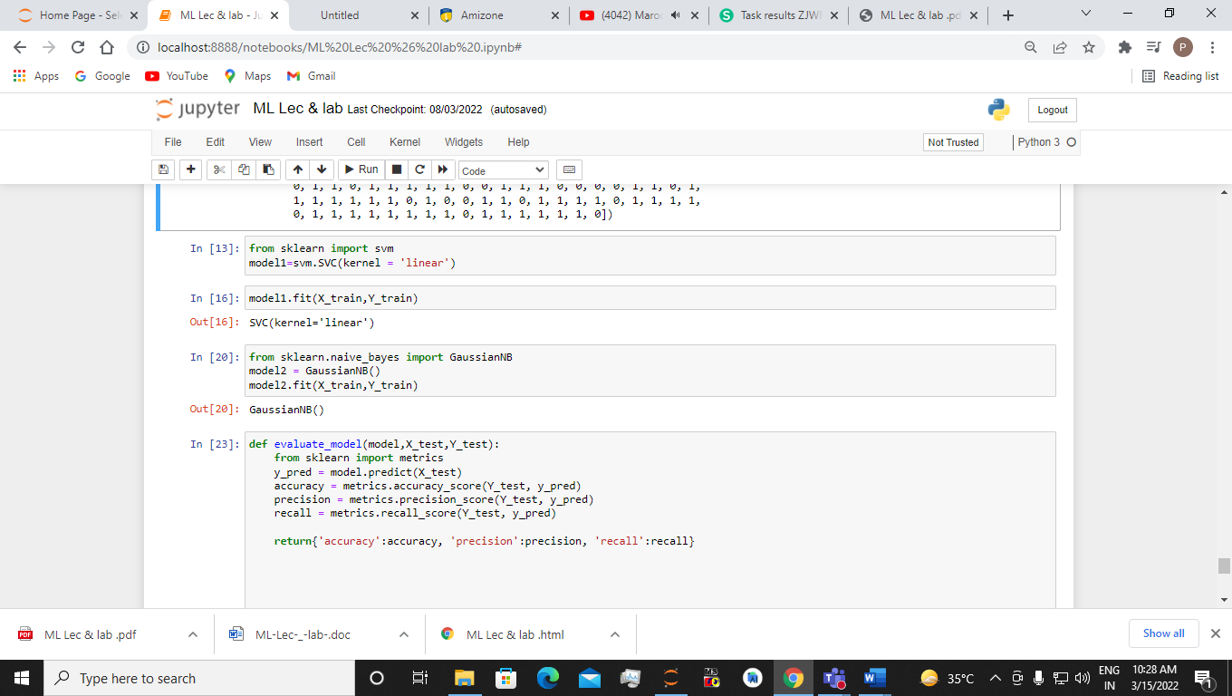

from sklearn.naive_bayes import GaussianNB

model2 = GaussianNB()

model2.fit(X_train,Y_train)



def evaluate_model(model,X_test,Y_test):

from sklearn import metrics

y_pred = model.predict(X_test)

accuracy = metrics.accuracy_score(Y_test, y_pred)

precision = metrics.precision_score(Y_test, y_pred)

recall = metrics.recall_score(Y_test, y_pred)

return{'accuracy':accuracy, 'precision':precision, 'recall':recall}

#evaluating SVM model

svm_eval_par=evaluate_model(model1,X_test,Y_test)

print(svm_eval_par)

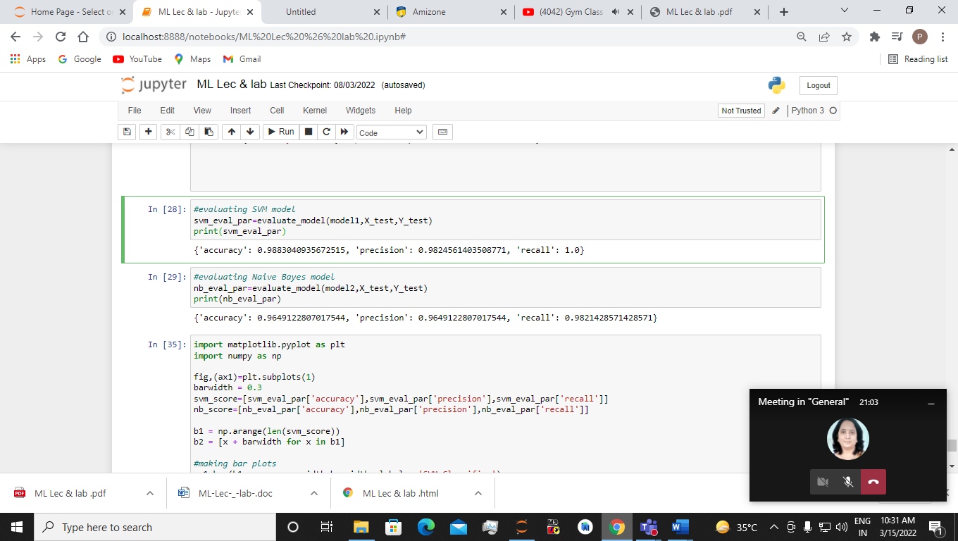

#evaluating Naive Bayes model

nb_eval_par=evaluate_model(model2,X_test,Y_test)

print(nb_eval_par)

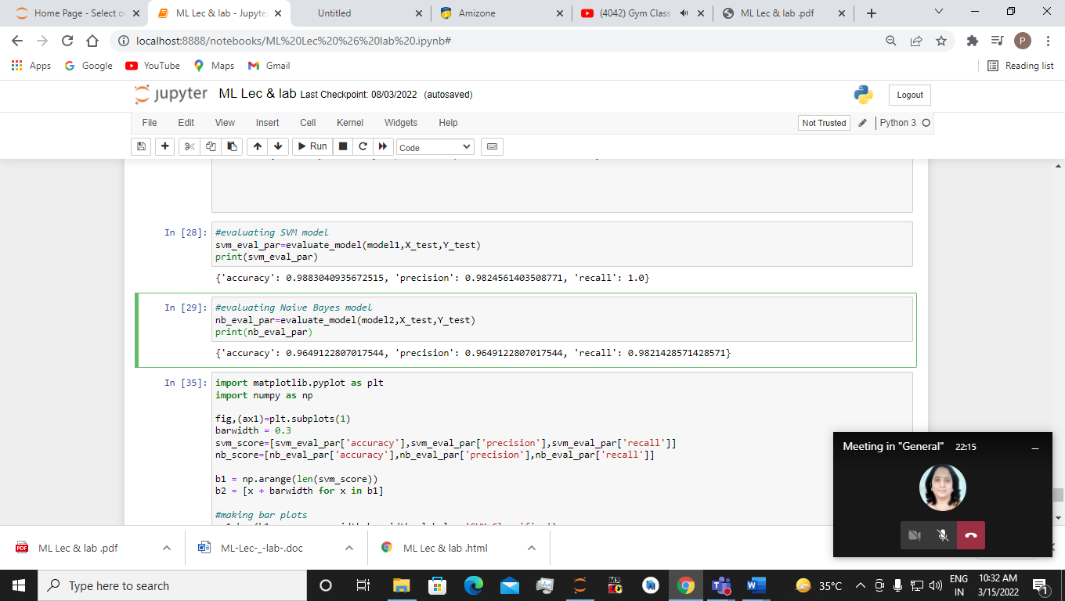

import matplotlib.pyplot as plt

import numpy as np

fig,(ax1)=plt.subplots(1)

barwidth = 0.3

svm_score=[svm_eval_par['accuracy'],svm_eval_par['precision'],svm_eval_par['recall']]

nb_score=[nb_eval_par['accuracy'],nb_eval_par['precision'],nb_eval_par['recall']]

b1 = np.arange(len(svm_score))

b2 = [x + barwidth for x in b1]

#making bar plots

ax1.bar(b1,svm_score, width=barwidth, label = 'SVM Classifier')

ax1.bar(b2,nb_score, width=barwidth, label = 'NB Classifier')

ax1.set_xlabel('Evaluation Metrices')

labels = ['Accuracy', 'Precision','Recall']

ax1.set_xticks([a + (barwidth *1.5)for a in range(len(svm_score))])

ax1.set_xticklabels(labels)

ax1.set_ylabel('Score')

ax1.set_ylim(0,1)

ax1.set_title('Evaluation Metrics', fontsize=14)

ax1.legend()

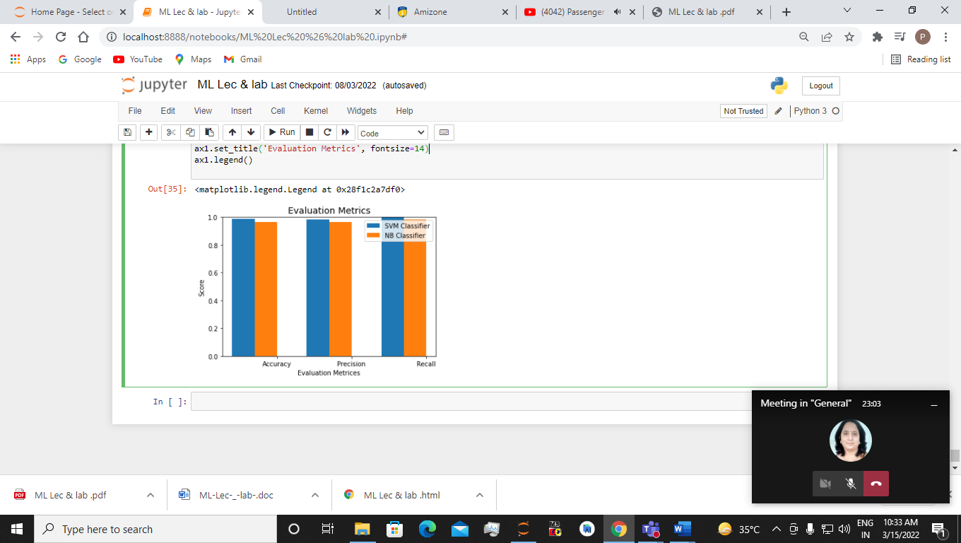

**EXPERIMENT 7**

Use an appropriate data set from standard repositories to implement clustering by k-means algorithmic technique. Comment on the cluster quality.

Sol:-

#30-3-22

import pandas as pd

import numpy as np

import matplotlib.pyplot as plt

from sklearn.cluster import KMeans

x=np.array([[1,1],

[2,1],

[4,3],

[5,4]])

x

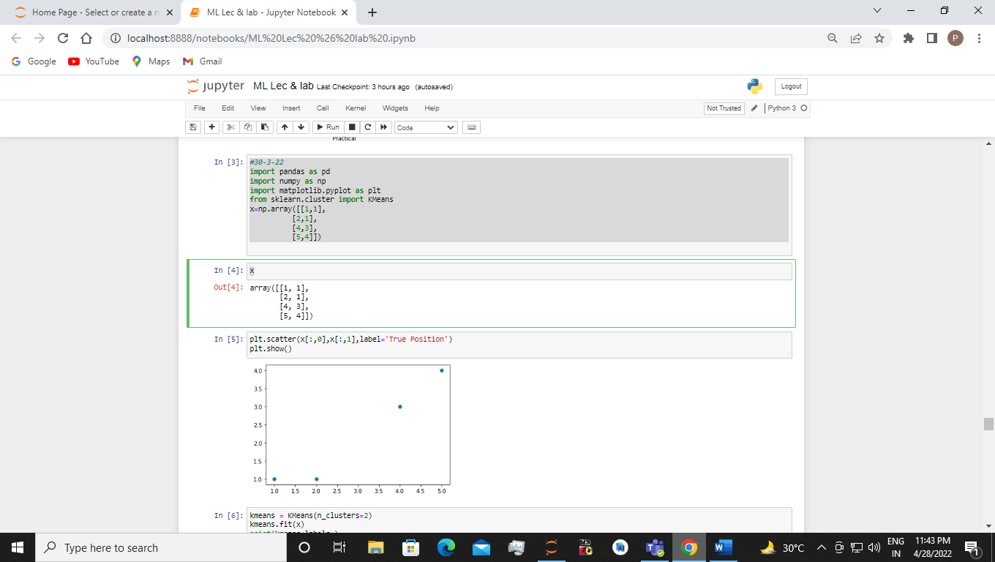

plt.scatter(x[:,0],x[:,1],label='True Position')

plt.show()

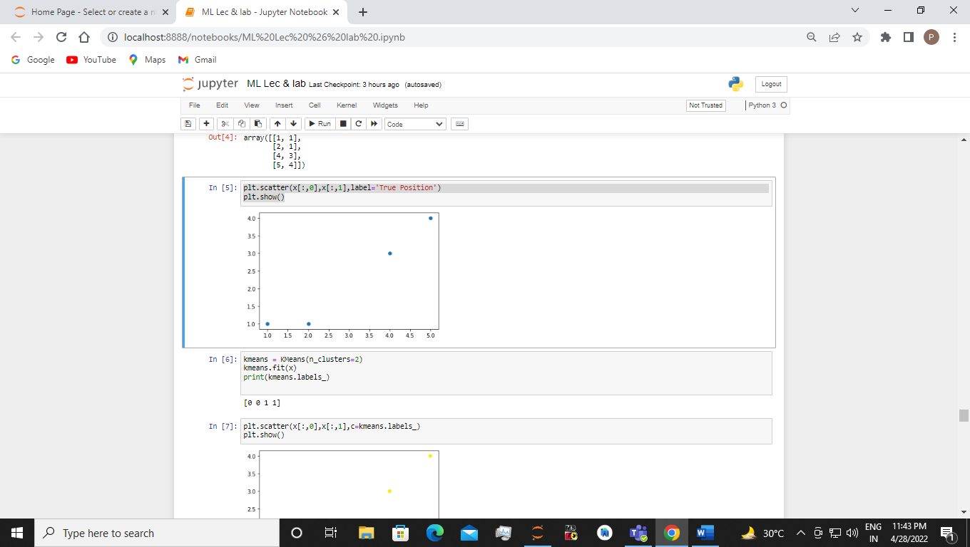

kmeans = KMeans(n_clusters=2)

kmeans.fit(x)

print(kmeans.labels_)

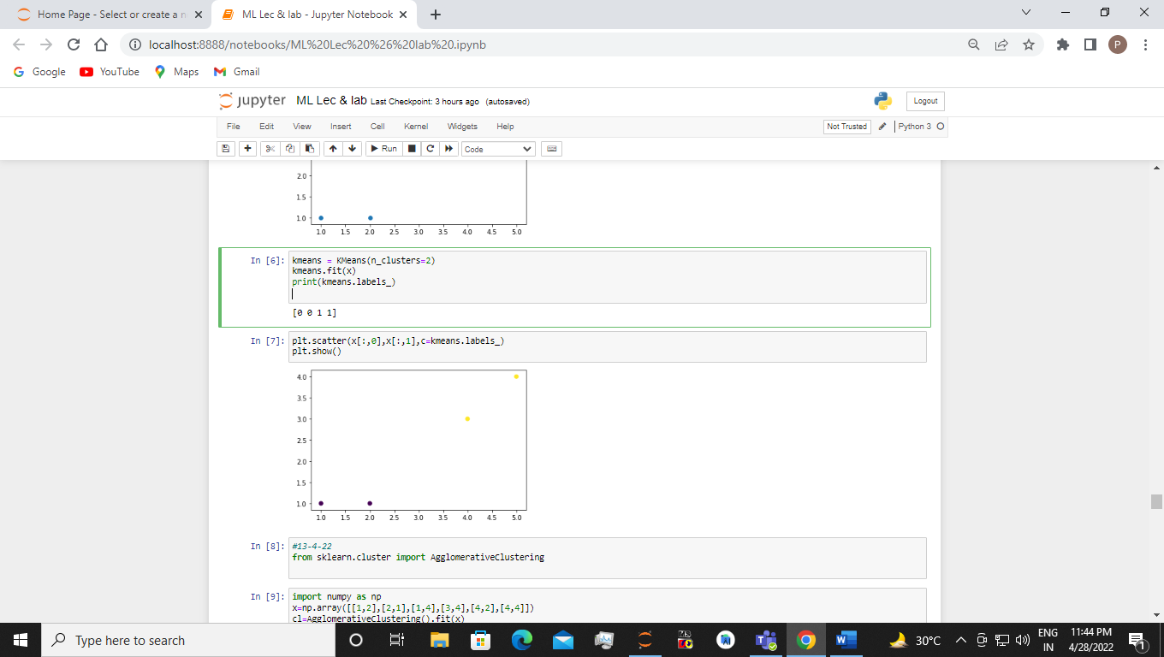

plt.scatter(x[:,0],x[:,1],c=kmeans.labels_)

plt.show()

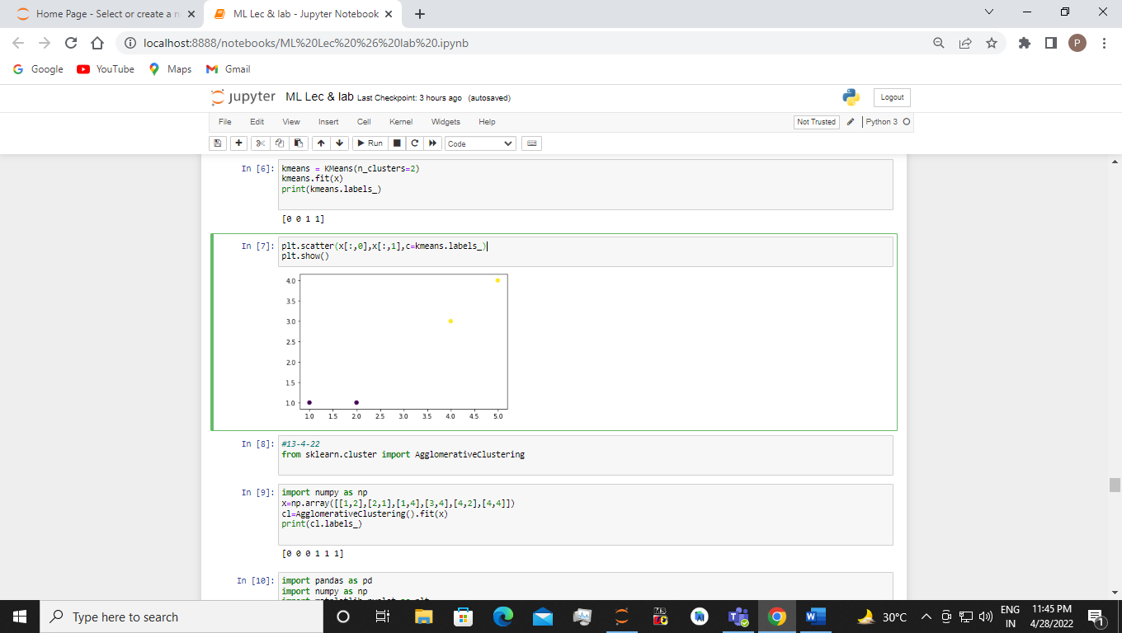

**EXPERIMENT 8**

Predict the gas consumption (in millions of gallons) in 48 of the US states based on petrol tax (in cents) . Use the simple linear regression algorithm via the Scikit-Learn Python library solves this regression problem.

Sol:-

import numpy as np

import pandas as pd

from sklearn.linear_model import LinearRegression

pt =pd.read_csv('petrol_consumption.csv')

pt

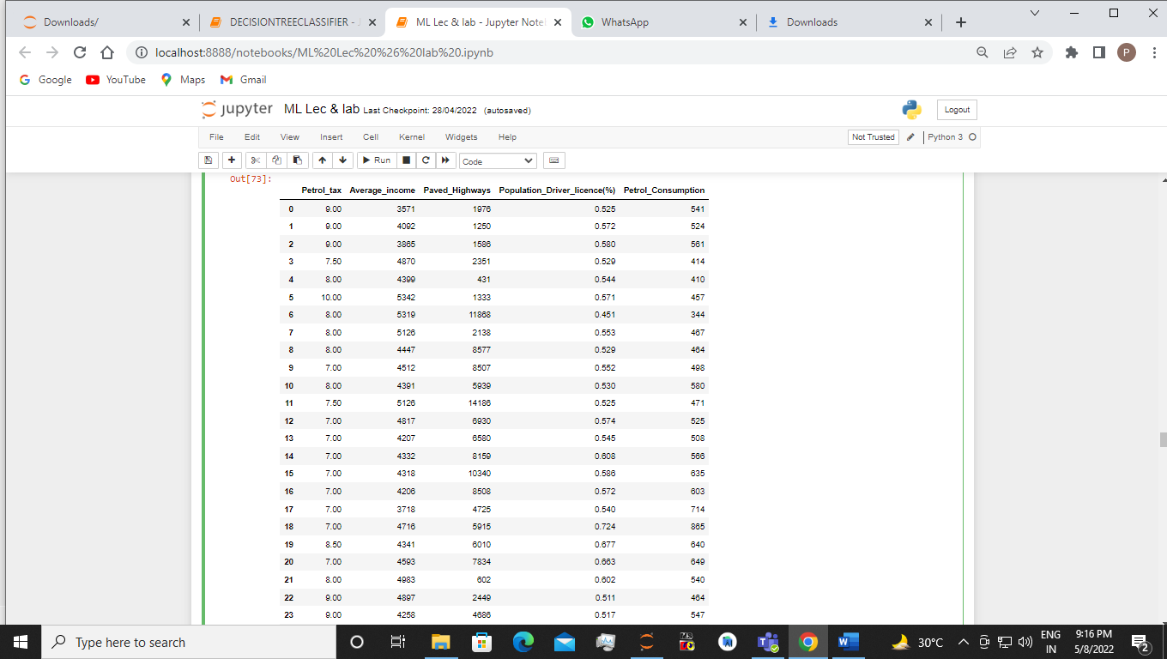

from sklearn.preprocessing import LabelEncoder

l=LabelEncoder()

pt.iloc[:,0]=l.fit_transform(pt.iloc[:,0])

pt

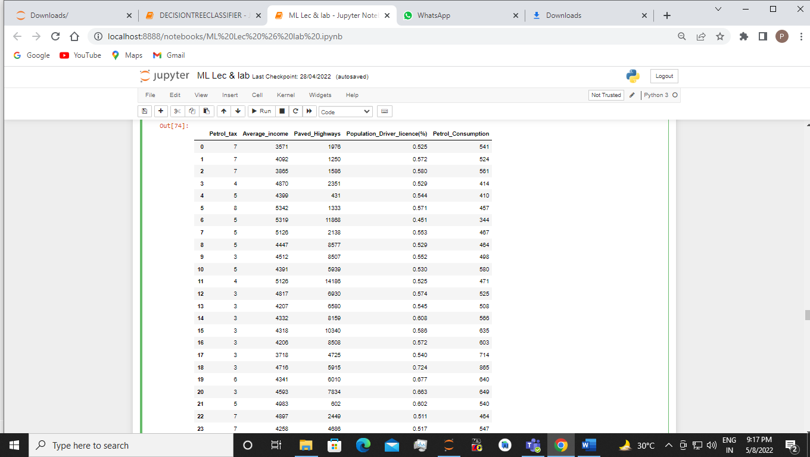

pt.shape

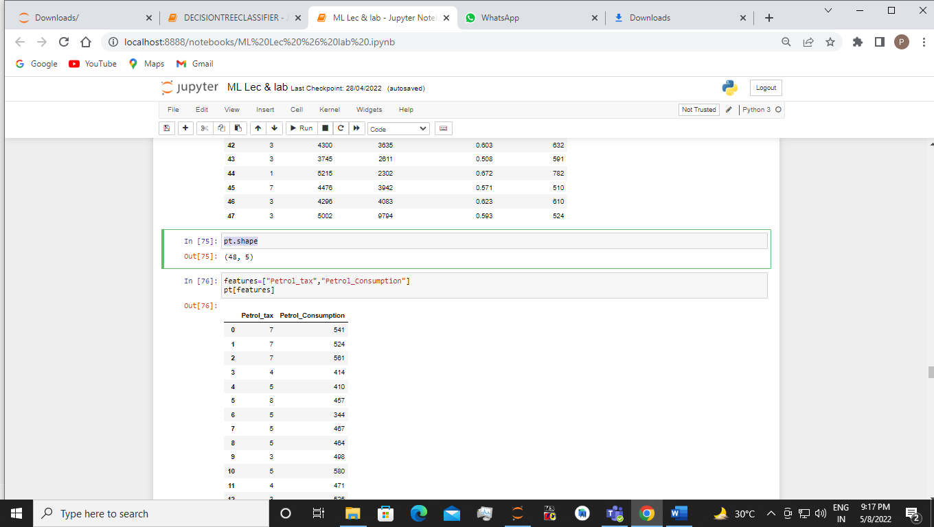

features=["Petrol_tax","Petrol_Consumption"]

pt[features]

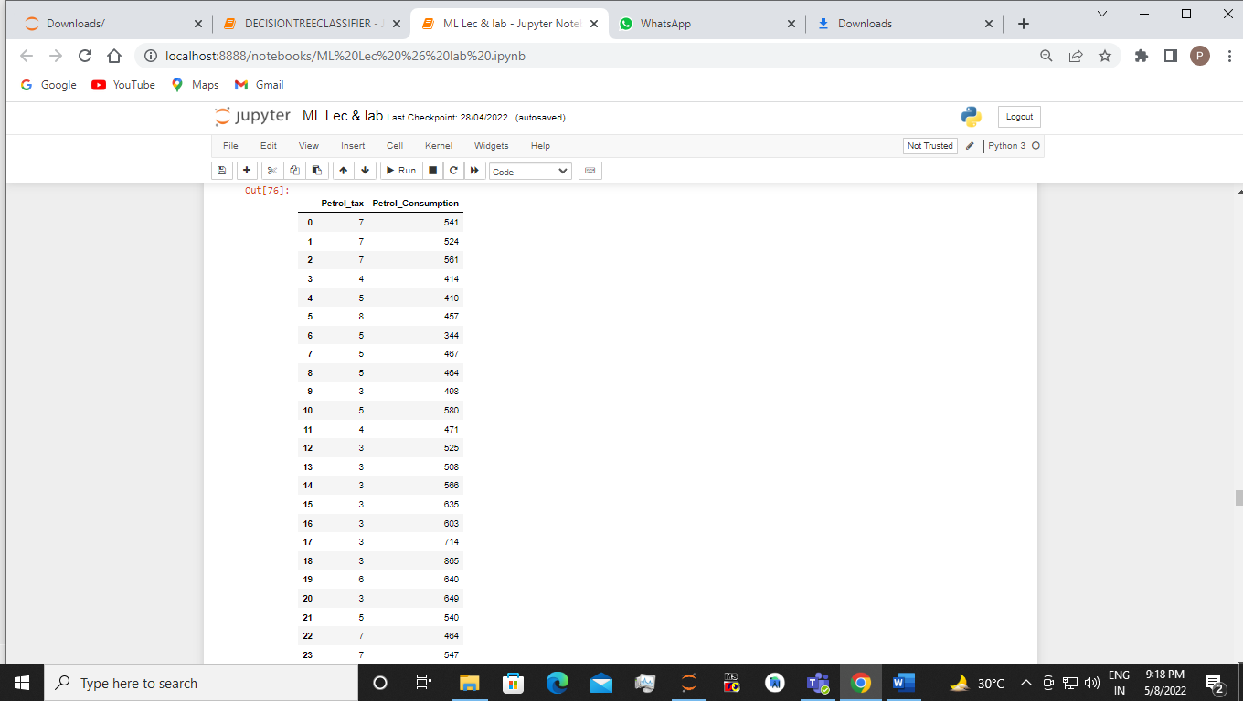

x_Petrol_tax=pt['Petrol_tax']

y_Petrol_Consumption=pt['Petrol_Consumption']

ax=np.array(x_Petrol_tax).reshape((-1,1))

ax

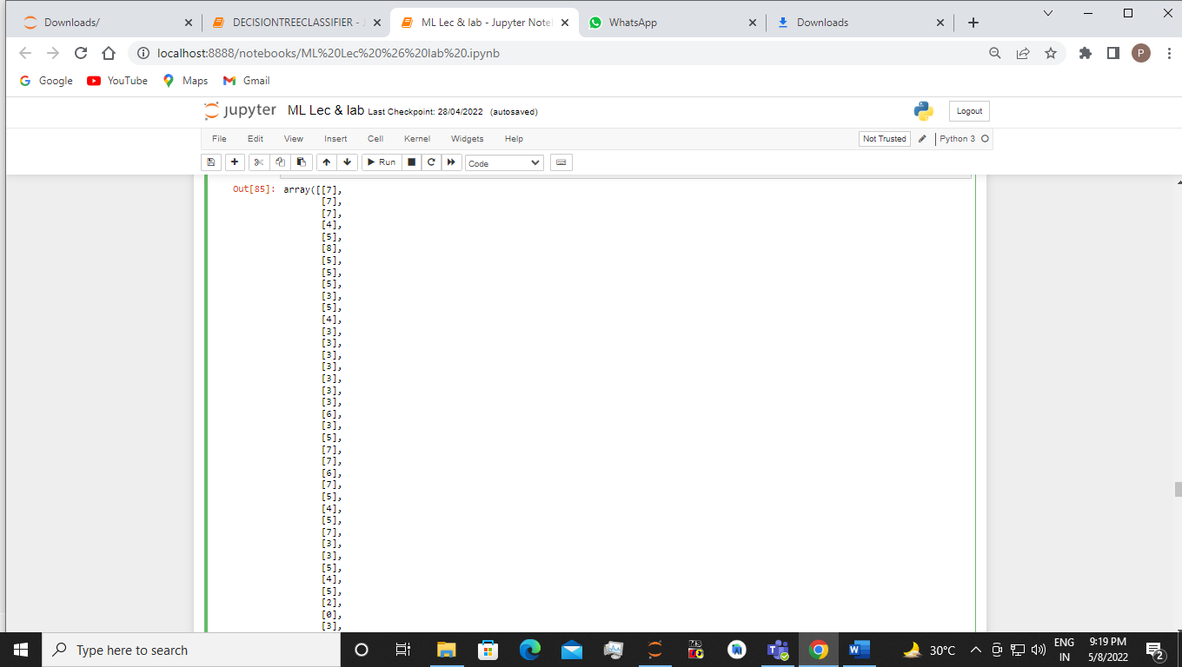

ay=np.array(y_Petrol_Consumption).reshape((-1,1))

ay

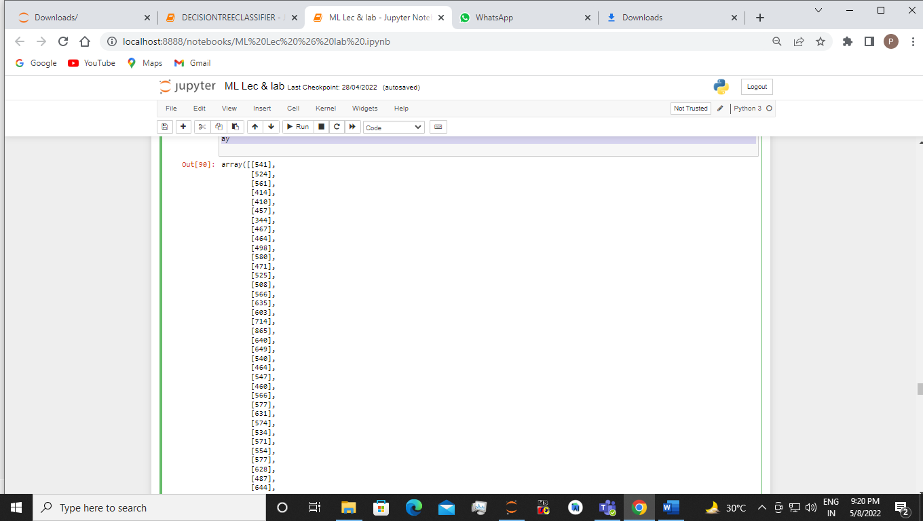

model=LinearRegression()

model.fit(ax,ay)

r_sq = model.score(ax,ay)

print("coefficient of determination:",r_sq)

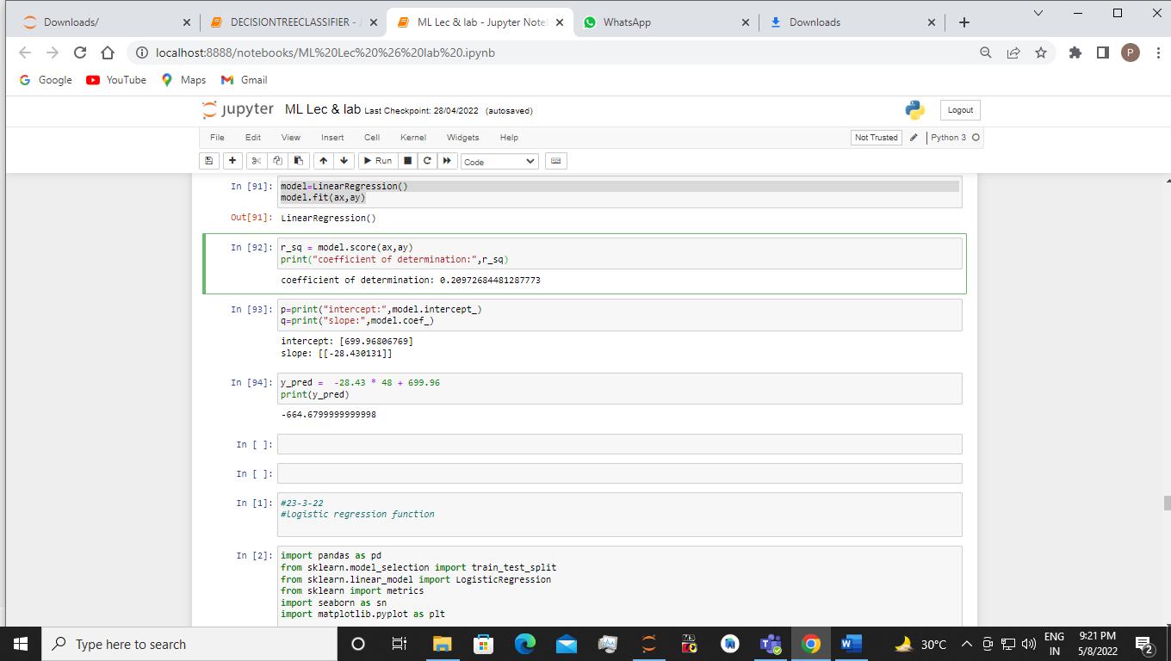

p=print("intercept:",model.intercept_)

q=print("slope:",model.coef_)

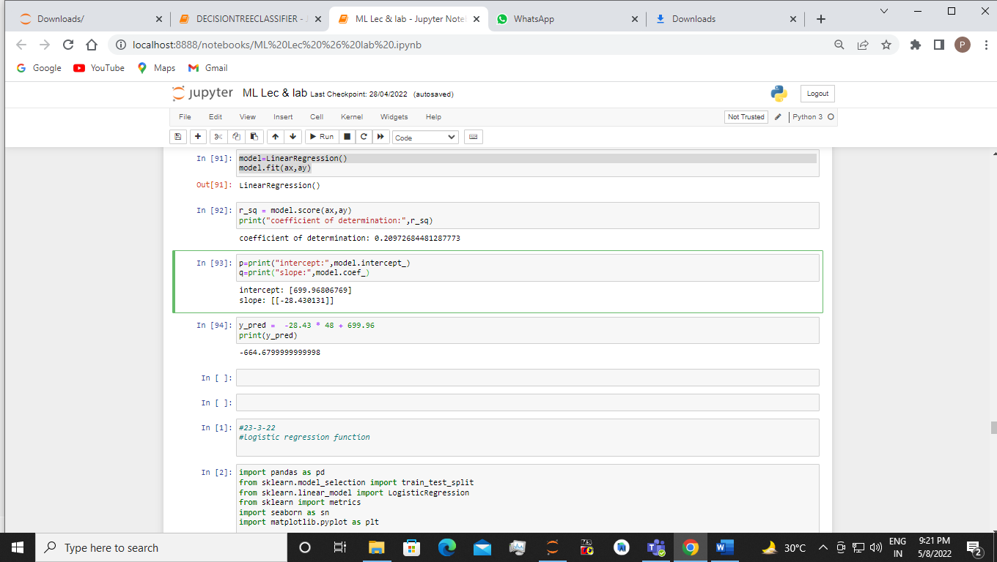

y_pred = -28.43 * 48 + 699.96

print(y_pred)

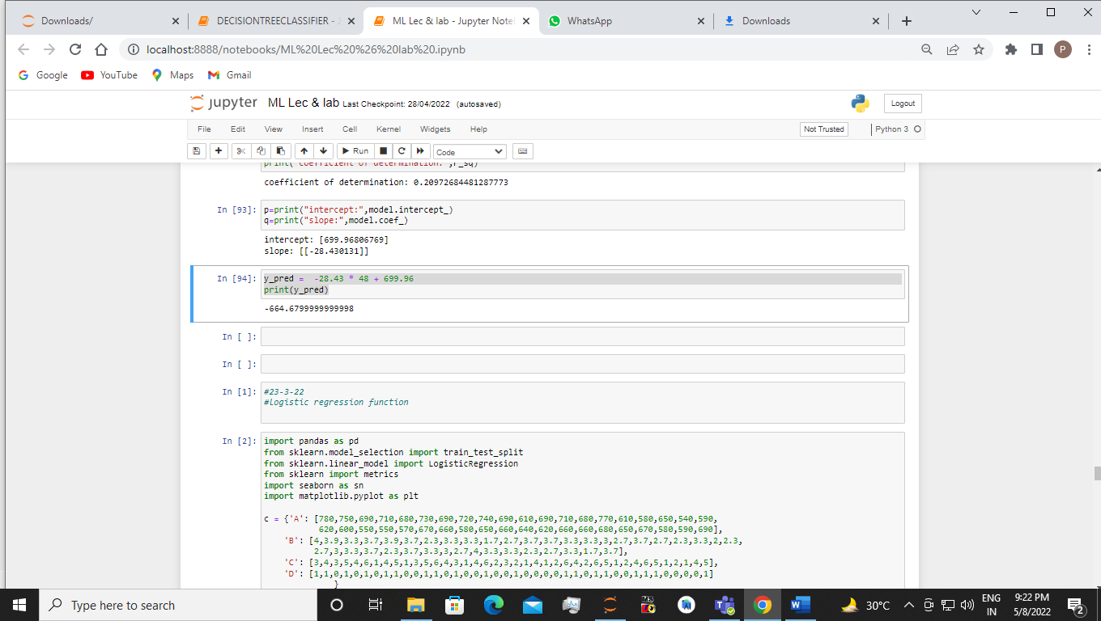

**EXPERIMENT 9**

Considering appropriate dataset and importing the required libraries build the model using Apriori algorithm to exhibit the construction of Association rules and further analyze the results.

Sol:-

#20-4-22

#apyori

import numpy as np

import pandas as pd

!pip install apyori

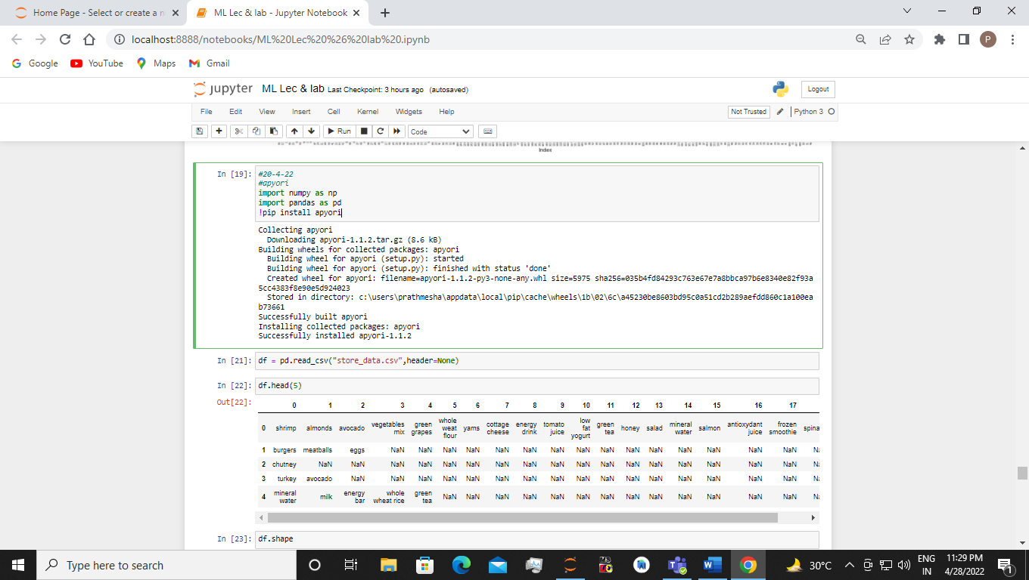

df = pd.read_csv("store_data.csv",header=None)

df.head(5)

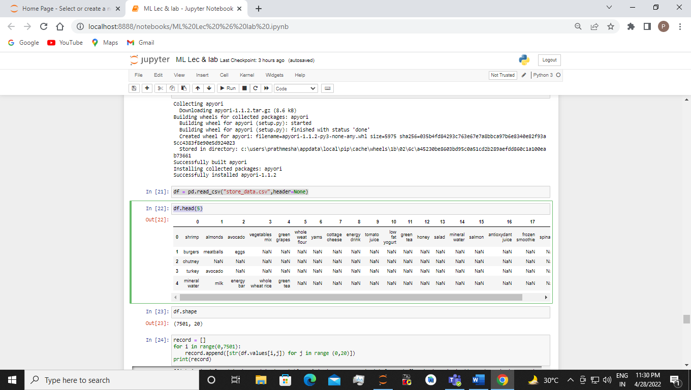

df.shape

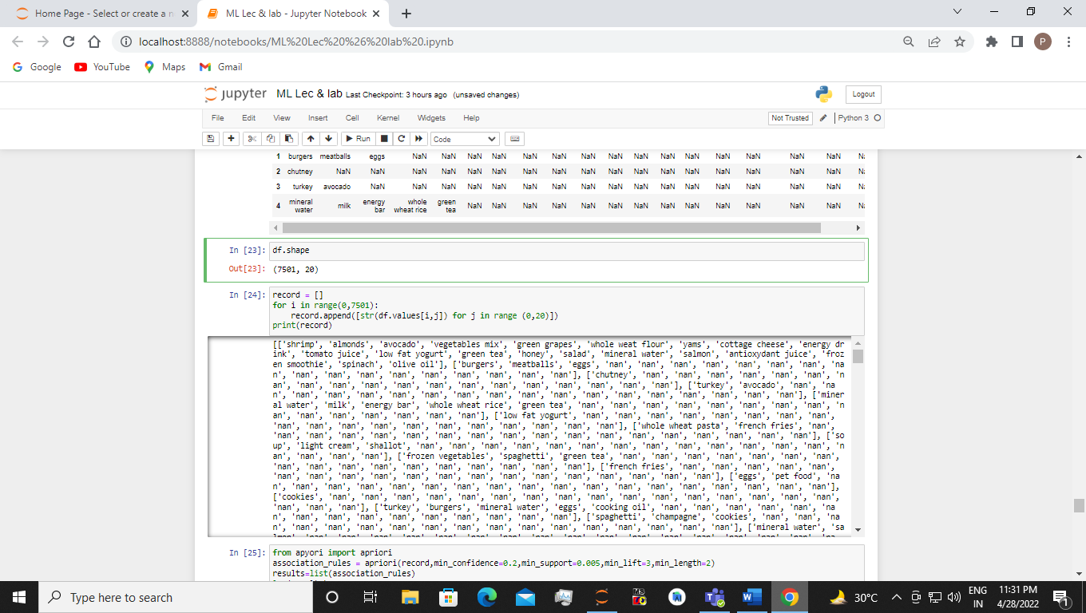

record = []

for i in range(0,7501):

record.append([str(df.values[i,j]) for j in range (0,20)])

print(record)

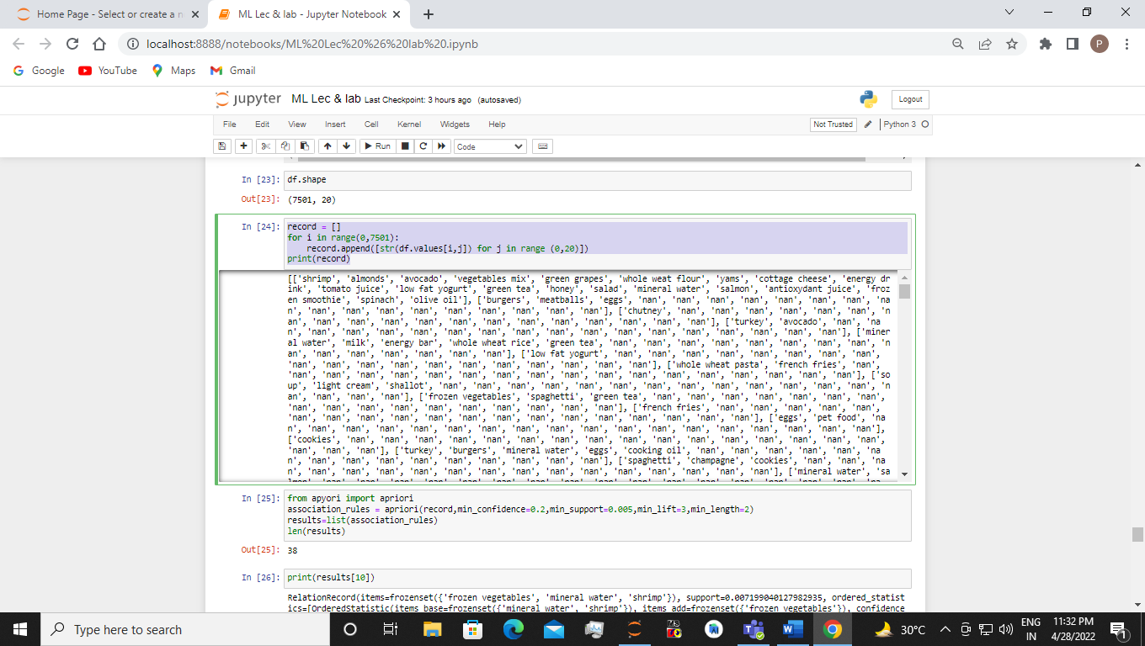

from apyori import apriori

association_rules = apriori(record,min_confidence=0.2,min_support=0.005,min_lift=3,min_length=2)

results=list(association_rules)

len(results)

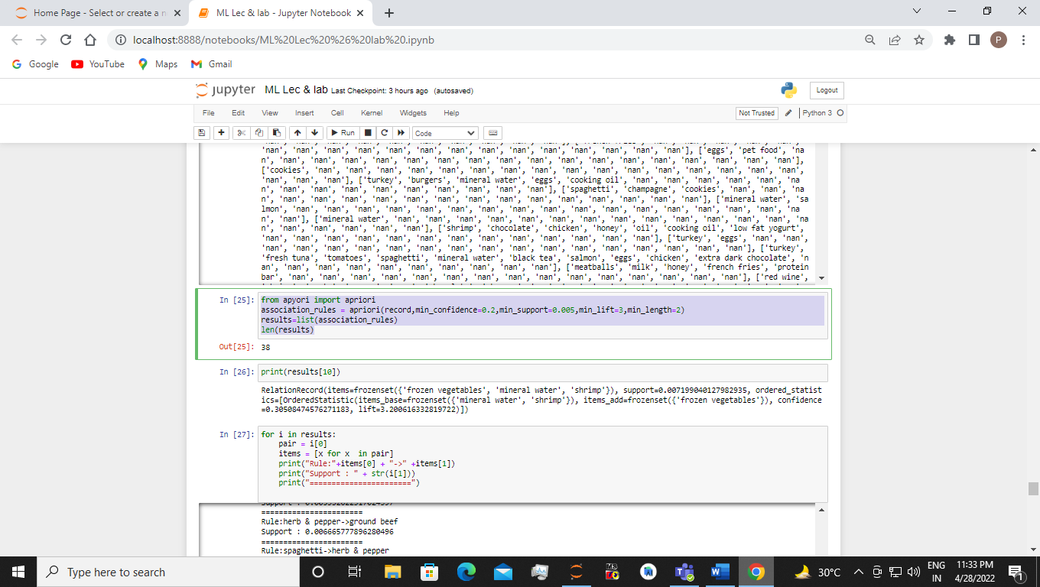

print(results[10])

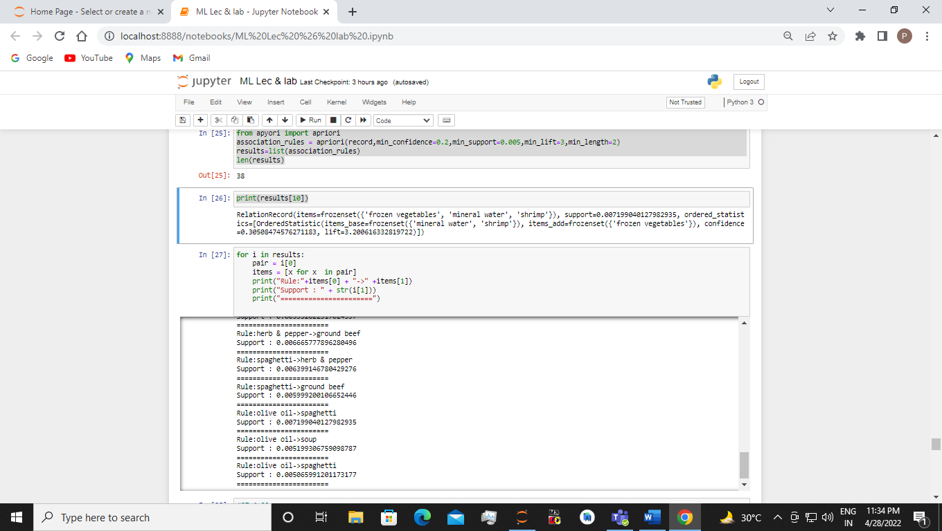

for i in results:

pair = i[0]

items = [x for x in pair]

print("Rule:"+items[0] + "->" +items[1])

print("Support : " + str(i[1]))

print("=======================")

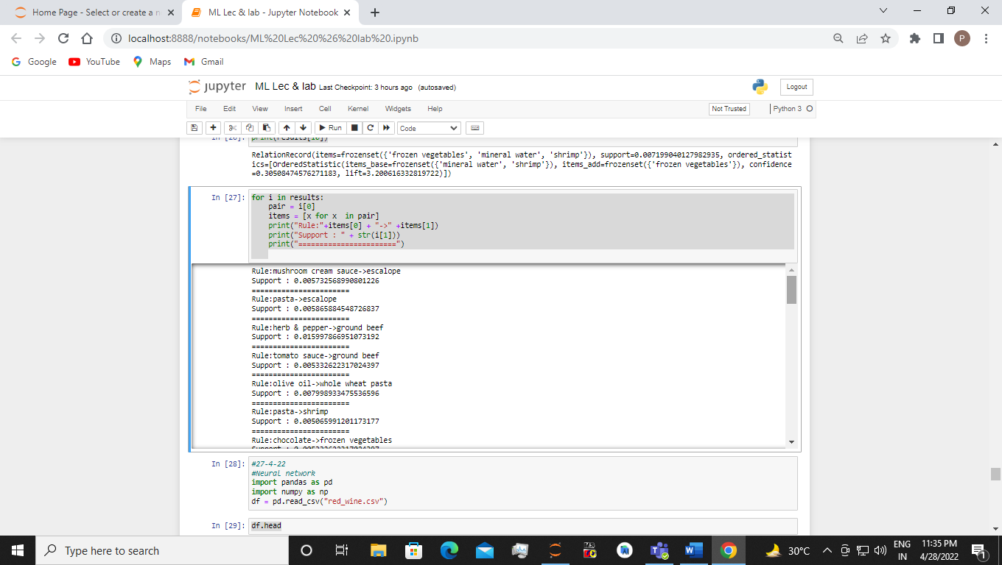

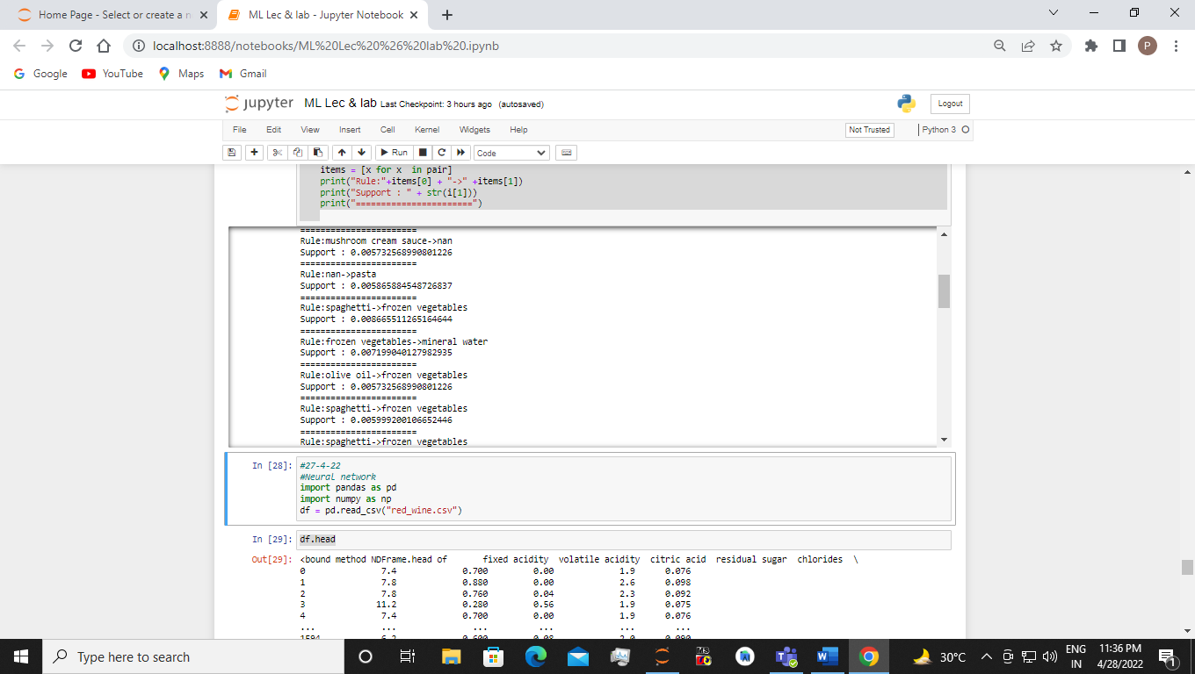

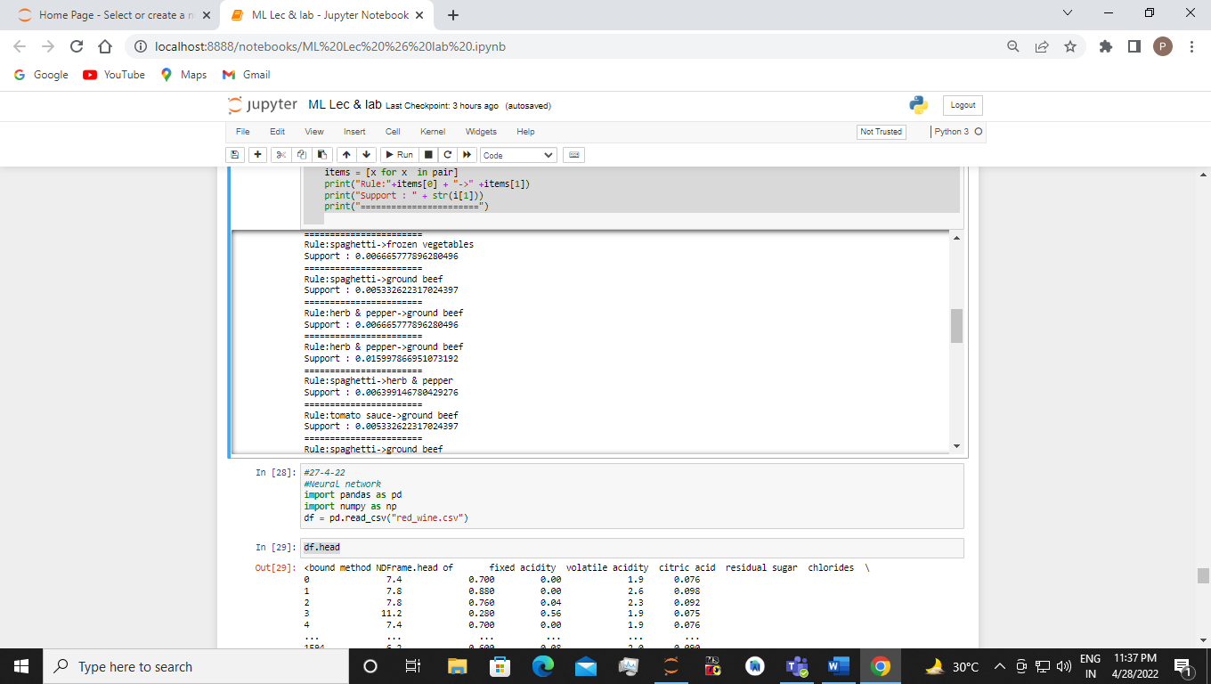

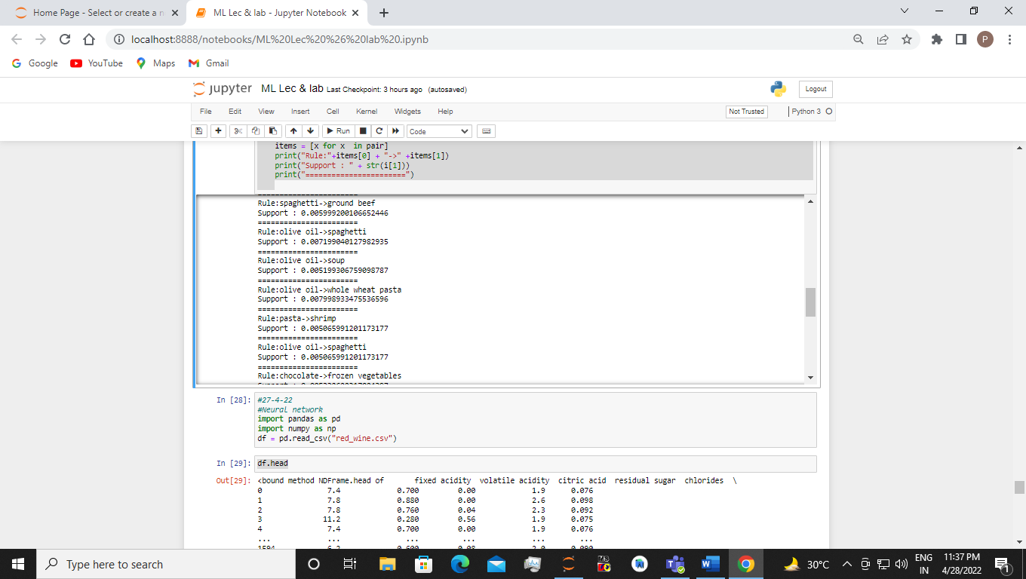

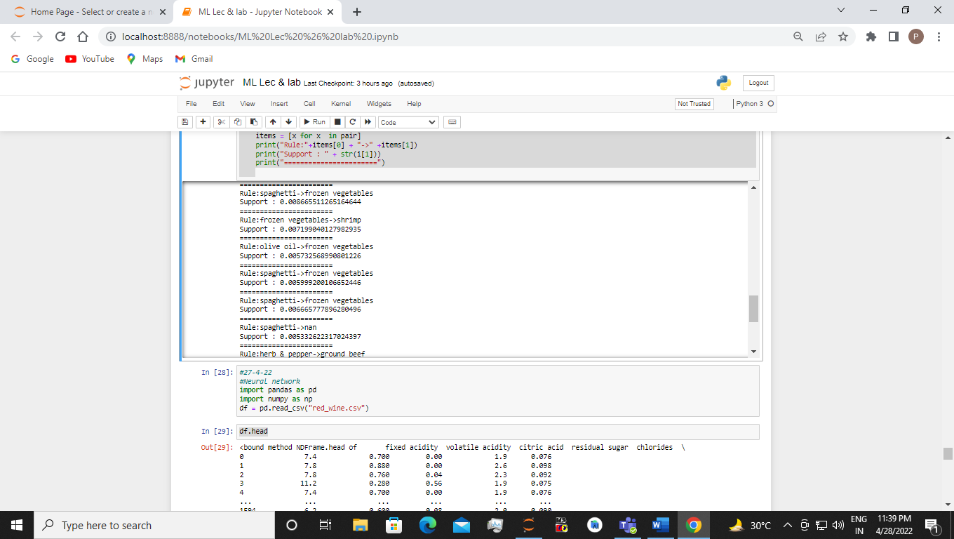

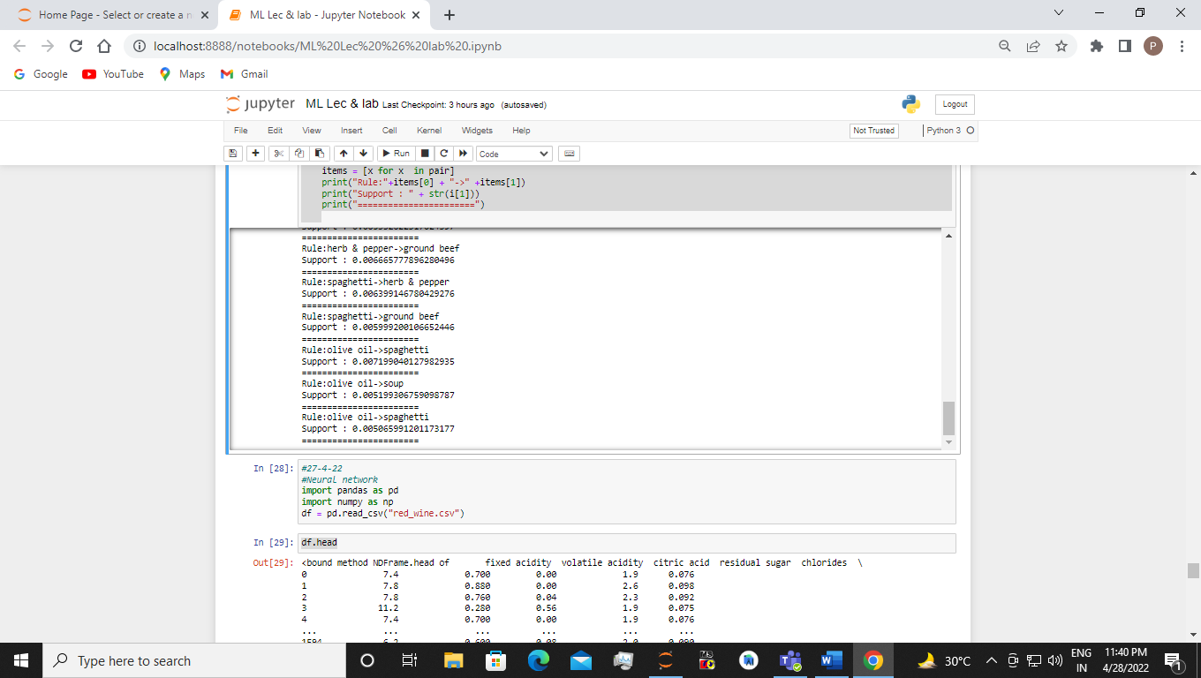

**EXPERIMENT 10**

Implement the Artificial Neural Network training process using sklearn library of Python.

Sol:-

#27-4-22

#Neural network

import pandas as pd

import numpy as np

df = pd.read_csv("red_wine.csv")

df.head



df.shape



#x independent features

#y dependent features

x= df.drop('quality',axis=1)

y= df['quality']



from sklearn.model_selection import train_test_split

x_train,x_test,y_train,y_test = train_test_split(x,y,test_size=0.25,shuffle=False)





from sklearn.preprocessing import StandardScaler

#it will help to standardize features by removing

#mean and scaling it a unit variance

scaler = StandardScaler()

scaler.fit(x_train)

StandardScaler()

scaler.fit(x_test)

x_train = scaler.transform(x_train)

x_test = scaler.transform(x_test)



#train my model

from sklearn.neural_network import MLPClassifier

mlp = MLPClassifier(hidden_layer_sizes = (13,13,13), max_iter=1500, activation = 'relu')

mlp.fit(x_train,y_train)



predictions = mlp.predict(x_test)

from sklearn.metrics import accuracy_score

print(accuracy_score(y_test,predictions)*100)



from sklearn.metrics import confusion_matrix

print(confusion_matrix(y_test,predictions))



from sklearn.metrics import classification_report

print(classification_report(y_test, predictions))

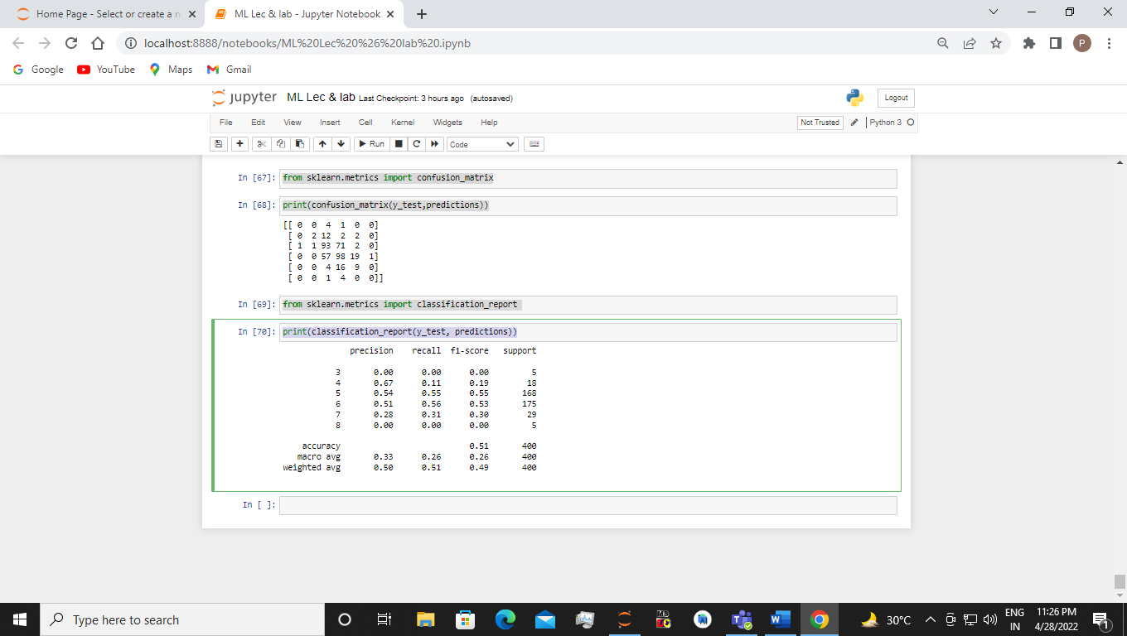

**EXPERIMENT 11**

Implement Artificial Neural Network using the Backpropagation algorithm and test the same using appropriate data sets

Sol:-

#11-5-2022

import numpy as np

from numpy import exp,random,array,dot

class NeuralNetwork:

def __init__(self):

## Seed the random number generator, so it generates the same numbers

# every time the program runs.

random.seed(1)

self.weight_matrix=2* random.random((3,1))-

def sig(self,x):

return 1/(1+ np.exp(-x))

def sig_derivative(self,x):

return x*(1-x)

def forward_propagation(self,inputs):

return self.sig(dot(inputs,self.weight_matrix))

def train(self,train_inputs,train_outputs, numofiterations):

for iteration in range(numofiterations):

output=self.forward_propagation(train_inputs)

error=train_outputs-output

adjustment=dot(train_inputs.T,error*self.sig_derivative(output))

self.weight_matrix+=adjustment

nn=NeuralNetwork()

print('Random weights at the start of training')

print(nn.weight_matrix)

training_input=array([[1,0,1],[0,0,1],[1,0,1],[1,1,0]])

training_output=array([[1,0,1,0]]).T

nn.train(training_input,training_output,10000)

print("New weights after training")

print(nn.weight_matrix)

print("Testing network on new examples-->")

print(nn.forward_propagation(array([1,0,0])))

Output:-

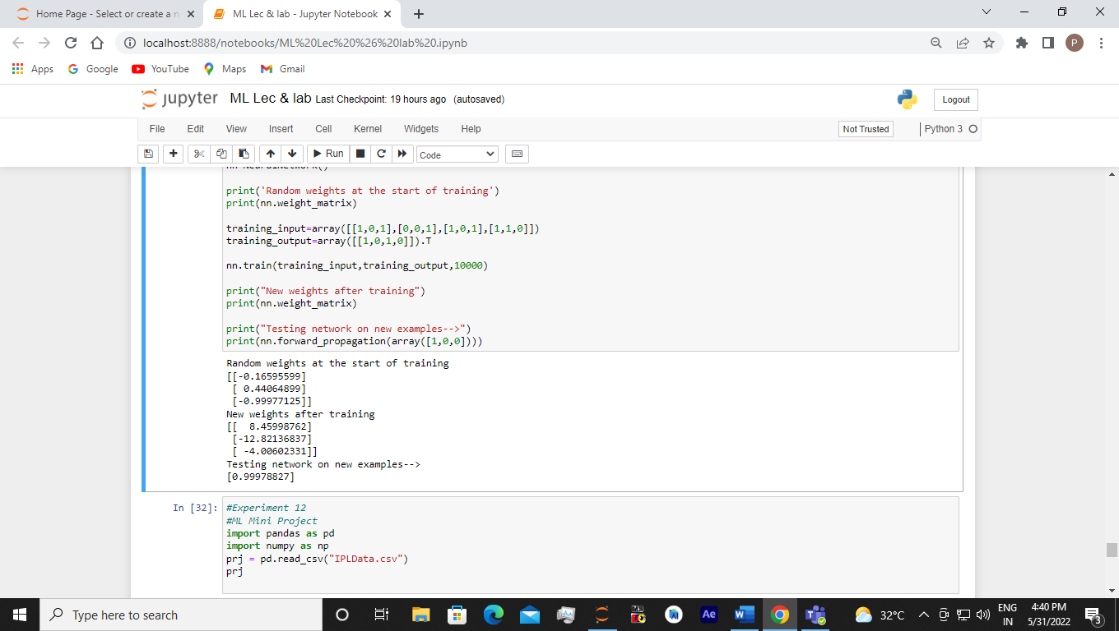

**EXPERIMENT 12**

ML Mini Project (Open ended) –Apply Machine Learning algorithms to solve real world problems.

Predicting overall runs made by players by their total played matches of IPL season 2022. Using the simple linear regression algorithm via the Scikit-Learn Python library.

Sol:-

#Experiment 12

#ML Mini Project

import pandas as pd

import numpy as np

prj = pd.read_csv("IPLData.csv")

prj

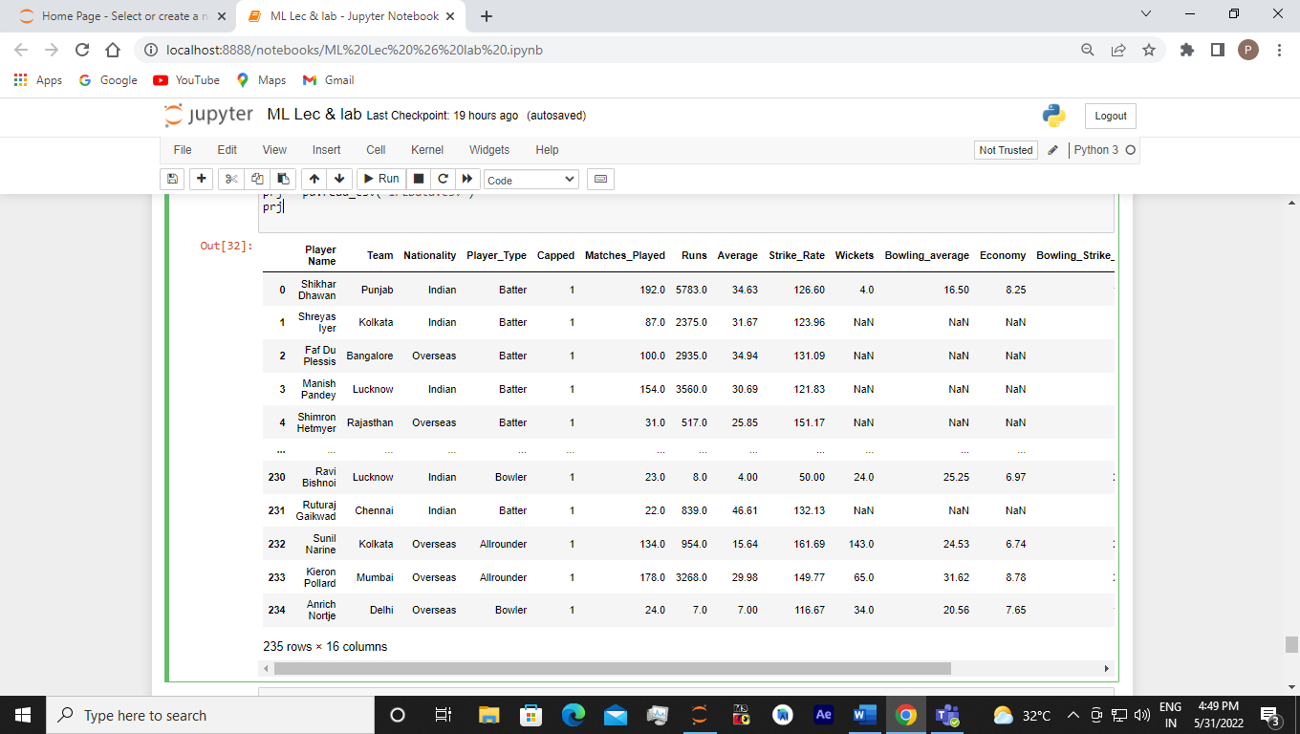

prj.shape

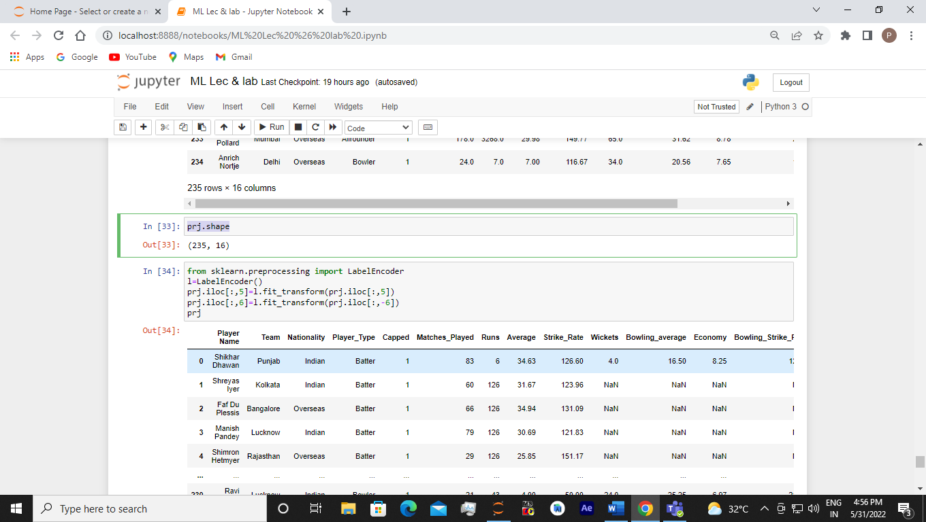

from sklearn.preprocessing import LabelEncoder

l=LabelEncoder()

prj.iloc[:,5]=l.fit_transform(prj.iloc[:,5])

prj.iloc[:,6]=l.fit_transform(prj.iloc[:,-6])

prj

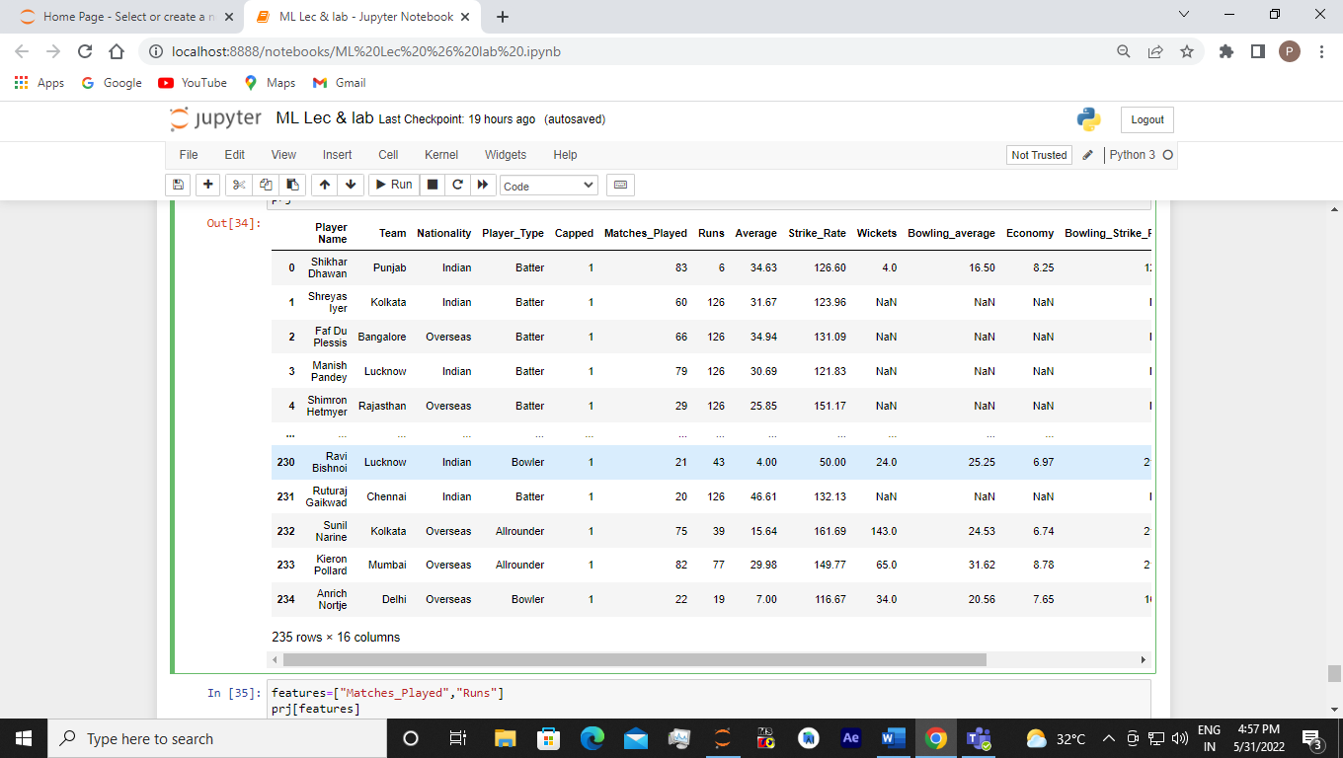

features=["Matches_Played","Runs"]

prj[features]

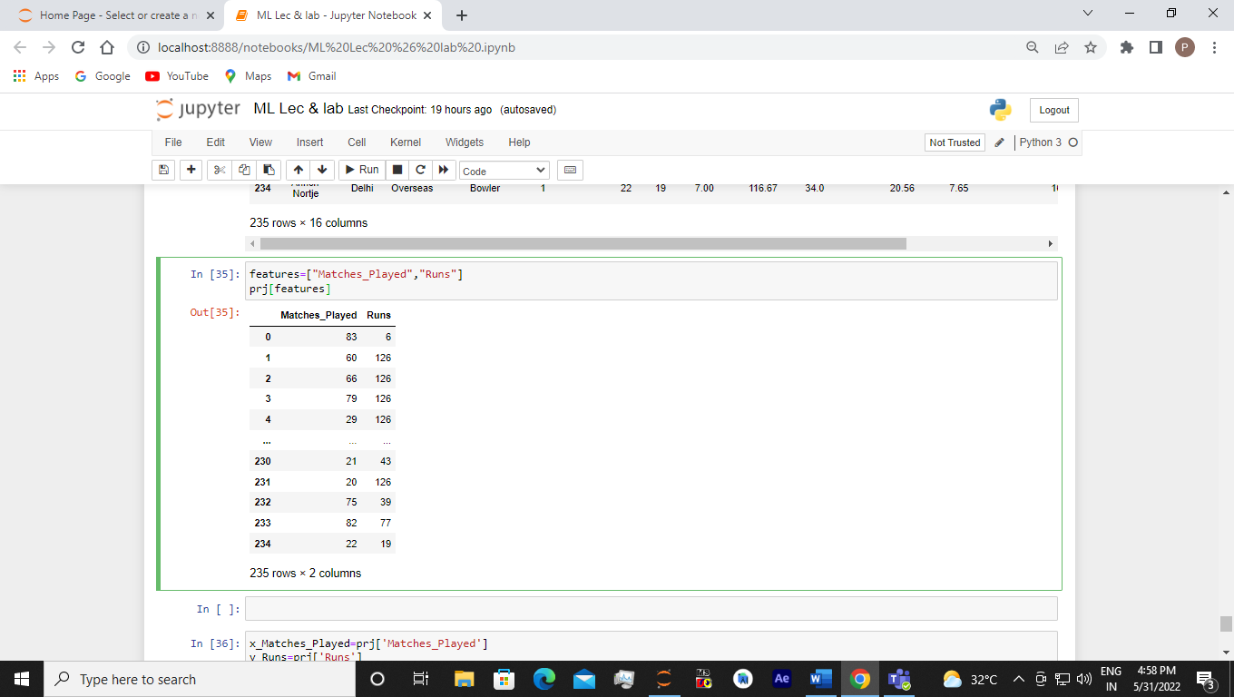

x_Matches_Played=prj['Matches_Played']

y_Runs=prj['Runs']

ax=np.array(x_Matches_Played).reshape((-1,1))

ax

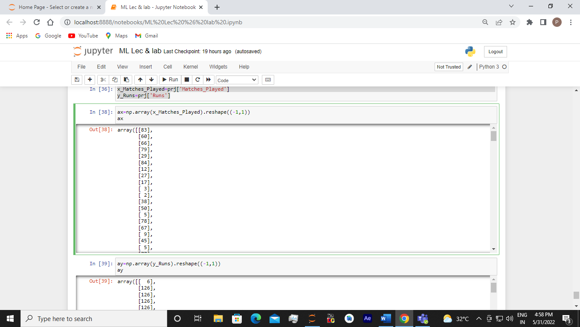

ay=np.array(y_Runs).reshape((-1,1))

ay

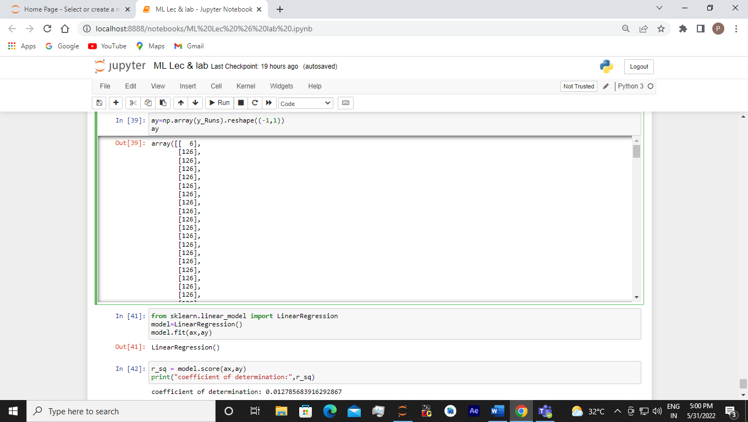

from sklearn.linear_model import LinearRegression

model=LinearRegression()

model.fit(ax,ay)

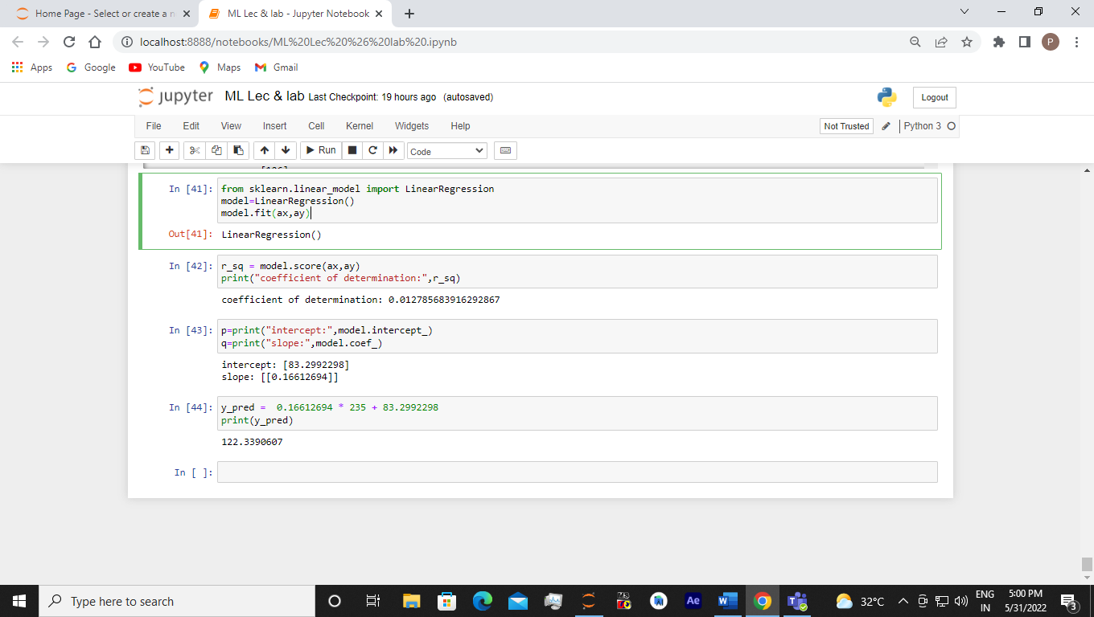

r_sq = model.score(ax,ay)

print("coefficient of determination:",r_sq)

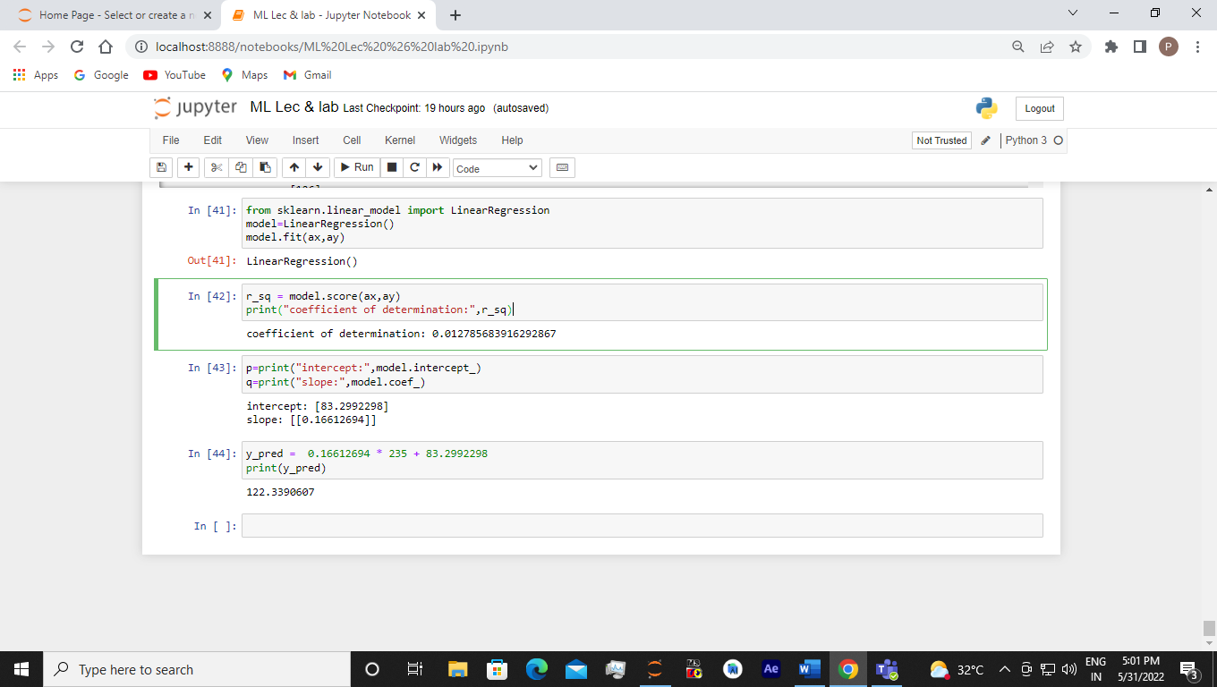

p=print("intercept:",model.intercept_)

q=print("slope:",model.coef_)

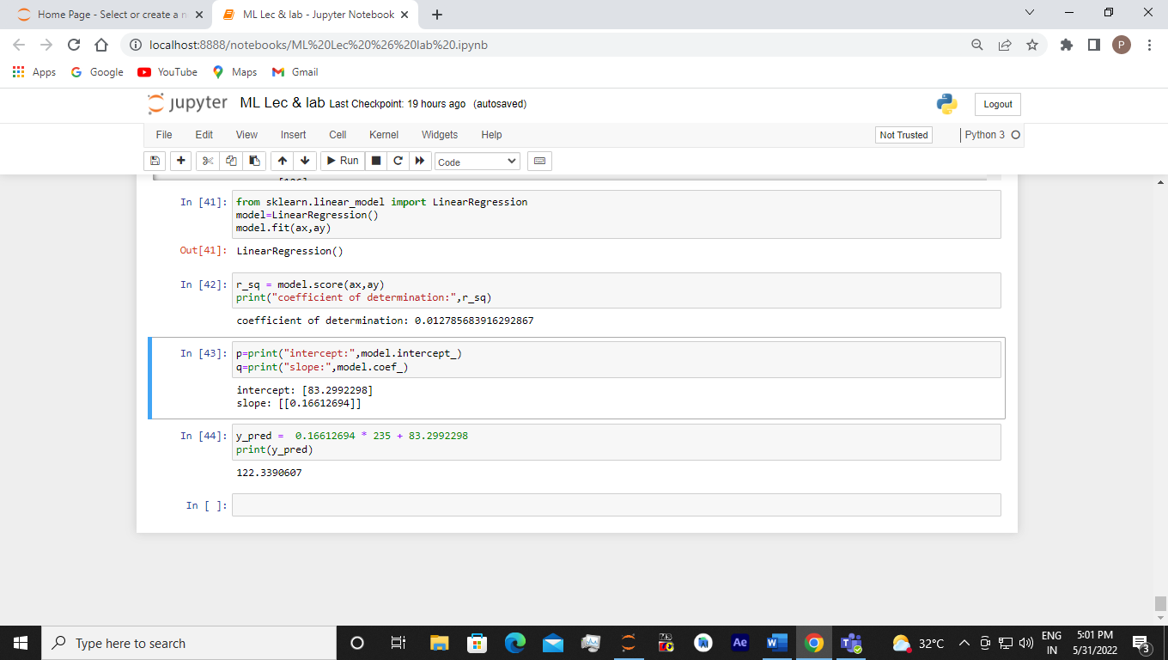

y_pred = 0.16612694 * 235 + 83.2992298

print(y_pred)

